Split File

SFM export for FLEX
I wanted to lay out my ideas for how the Split File feature would be implemented. As time goes on we can refine these details.

There are actually two parts to the Split File feature:
Audio File support and Data File support.

So far I’ve only talked about Audio File support. There will also need to be a version 1 and then a version 2.

The Data File will contain the information that a user enters. i.e. Ref, Phonetic, Gloss, and other Meta Data like Language, Speaker name, Date, ... All of this data needs to be exported from SA and imported into the linguistic program that people are using these days called FLEx (Fieldworks Language Explorer). The SFM export of the Data File from SA needs to be imported into FLEx. For now I plan to work on this design and implementation by using the SFM Import feature in FLEx. In the future a new feature needs to be added to the SA Export list to support exporting in LIFT format.

Split File version 2 will require a dialog box to support all of the new user options since they will not fit in the current customized Save As control. That is to say, in the future the selection of File/ Save As could bring up a dialog box first, the show the Windows Save As control regardless of what kind of saving the user wants to do.

Below is a chart showing the differences between what needs to be done now verses what might be done in the future after we have proven the initial concept of Split
File.

Feature in SA
version 1
version 2
version 3

Open Recording
File/ Open
File/ Open
File/ Open

Parse Recording
Tools/ Experimental Features/ Auto Parse1

and Manual editing
Enhanced Auto Parse

and Manual editing
Based on ref markers

and Manual editing

Ref data
Manual entry
Pre-Fill from Wordlist Doc file
Speech recognition of 0-9

Phonetic data
Manual entry
Manual entry
Speech recognition of Vowels

Speech recognition of Cons. (?)

Gloss data
Manual entry
Pre-Fill from Wordlist Doc file
Pre-Fill from Wordlist

Meta Data
<not supported>
File/ Information/ Source
File/ Information { all tabs }

Audio Folder name
“Split”
User selectable
User selectable

Audio Filename
Ref & Gloss
User selectable including any Transcription Bar names
User selectable including any Transcription Bar names

Folder Location
In current open file
User selectable
User selectable

Save As
Updated Save As dialog box
Use new setup dialog box

Also save All data in Ref and also a selected single word within Ref
Use setup dialog box

File/ Export
Use SFM Export
New Export/ LIFT option
New Export/ LIFT

Controlling Size of Gloss Field in a split file.
I've noticed a problem with working with a split file.
SA is designed such that when a wave file is opened then the Begin and End cursors are intentionally set slightly inset from the ends so that a user
can see them and click on them.

Currently when I open a newly written split file, since the Gloss is the entire width of the recording, the cursors are just at the window edge and not visible, but the real problem is that even if I get to them (i.e. by doing a left or right mouse click) then I cannot edit the size of the gloss
(e.g. I want it to be slightly smaller), because I am not able to click in Phonetic and grab a cursor to do this resizing, since the cursors are out of view. I don't yet know how to solve this problem. My current thought is to pad the ends of the file with two hundred milliseconds of silence so that there is place to locate the cursors.

12/23/11 – Standard Format Markers for FLEX
1) Could you please supply a sample file with phrase-level data?

The Phrase Level data is a marking of the entire event of one item in a word list.
We currently need to support two levels: L1 & L2
Their usage is:
L1: \xv example sentence-vernacular
L2: \xe example sentence-English

During Export, we can use these SFM markers as the default ones for Phrase Level data.
I've attached a list of common SFM markers.

The purpose of Phrase Level is to identify each event in a word list and mark it.
There may be no information entered into the Transcription Bar, but if there is, L1 is the place to put a vernacular (local village language) transcription of what is said. Since many times there is no way to write the vernacular language on day one, the IPA is used to transcribe the audio. Since L2 is the English version, then the data will be in English. It's possible for L1 to be blank and L2 to be filled (with something).

From a previous set of comments a 'typical' event for one word in a word list might be this as entered in L2:
Number One - Sun (spoken in English) - Sun (spoken in the National language -
i.e.Thai) - Sun (spoken three times, for clarity, spoken in the vernacular village language - i.e. Shan) - The sun is bright (spoken in the vernacular village language to give an example of the word being used in a phrase or sentence).

The reason the survey person (linguist) first says Number One and Sun in English is because they are native English speakers or the person who will work with the data needs to understand what the event is and English is expected to be understood by any linguist, so the survey person speaks in English so 'everyone' can understand what event this is in the word list.

Next the survey person says the English work in a language that they also know, but the village person also knows since the village person does not know English.

Next the village person responds by speaking the work in the village language three times and then using it in a phrase.

I’ve attached a simple version using Phrase List data.

3) I'm currently retrieving a copy of Flex to play with.

Flex is a large complex to use program. I am expecting you and I to need to fine tune the Import of SA data when SA is able to support the things FLEx needs. Since you want to look at FLEx, then get the latest version (since it’s very different from v6) here:
http://fieldworks.sil.org/download and select “7.0.6 SE Minimal (90 MB)”. You do not need version 6. If you installed it, then uninstall it. You also do not SQL Server with version 7; it is HTML based.

ATTACHMENTS
SFM_Markers.txt
1234-Full-PL.zip

SAMPLE: Word List : Kayan Example

I talked with Ken today regarding the exact process a user would go through when entering word list data (entering story data will be a future task for me to figure out).

The steps are:
- Researcher goes to a remote village.
- They find a native speaker of the local language.
- The Researcher explains what they want record some words.
- Audio recording is done on a hand-held digital recorder.
- The Researcher speaks the word list number and the word in the national language.
- The native speaker says the word three times in the local language.
- The Researcher later transcribes the local language into IPA in a notebook.

At some later time the Researcher would use SA and open the audio file.
The first step is to mark the location of each phrase.

{ In the supplied sample I've marked 3 phrases. }

The next step is starting at the beginning of the file, and enter the IPA for the Phrase in L1, and Gloss of the Phrase in L2.
The next step is to start at the beginning and mark the location of the best production of the single word.
{ e.g. I've marked the first word in word list item number three }
The next step is that the Researcher will use the Split file feature in SA.

Here are the details of what SA needs to do:
When the Researcher does the first pass through the file, all transcription fields will be the same width, as you can see in the word list item #1, the
Ref, Phonetic, Gloss, L1 and L2 are all the same.

When the Researcher does the second pass through the file the Ref, Phonetic,
Gloss transcription fields are changed to mark the best production of a single native word, as you can see in the word list item #2.

During the first pass, the Researcher places the cursors around the production of the first item in the word list. This is a phrase level marking, it includes everything that is related to Word #1 in the word list
(i.e. Ref, Gloss, National Gloss, native word, native word, native word, optional sentence showing usage of the word).

The steps that a Researcher needs to take to mark these levels are:
Position the cursors around the phrase data, and
. Select Edit/ Transcription/ Add Phonetic Segment
. Select Edit/ Transcription/ Add Gloss Word Segment
(note: Ref is a side effect of Add Gloss Word)
. Select Edit/ Transcription/ Add Phrase L1 Segment
. Select Edit/ Transcription/ Add Phrase L2 Segment

This is way too tedious, so I suggest you add an item to right-mouse click pop dialog box called "Mark Split File segment".

Next the Researcher needs to:
- Go to the beginning of the file,
- Select Edit/ Segment Boundaries
- Select the first Phrase Level segment by clicking it's "?" and click
- Playback/ Between Cursors
- After they determine the best production of one of the local language 3
- single words,
- Select the Phonetic Segment "?" and click on the Begin cursor and align it to the left edge of that word and, click on the End cursor and position it at the end of that word.
- Then the Researcher enters the IPA for that word

{ There is a faster way to do this using the Transcription Editor, but I want to get SA to work this way first, before we deal with changes needed in the Transcription Editor }

The last step is to use File/ Split File.

Changes that need to be made in SA:

- It's obvious that Ken is now talking about both Word level markup and a new Phrase level markup.
The reason for the two markups is first "preserve the complete recording event for each word" and second "satisfy the need for hearing the playback of a single word example". The FLEx program is basically a big dictionary building program. Thus in a electronic dictionary you have an example for the word itself and then maybe an example of it's usage in a sentence. The Researcher may not record an example sentence, but they do get things that are part of the process of getting the word itself. Thus there are two links in FLEx, one for audio for the single word and one for the example sentence.

The two files now need two names, so I suggest that SA use the Ref+Gloss for the single word as we have discussed, and by default (not user changeable at this time) call the other file Ref+Gloss -Phrase (that is "001 Sun-Phrase.wav").

- SA has two different systems for handling Segment Boundary: "Touching Segments" and "Non-Touching Segments".
In the attached "Saung Du La" recording, click the Edit Boundaries button, click the "?" in Phonetic for Word #2, now left-mouse click the end cursor, don't move your hand, but notice on the mouse down, that the Phonetic for Word #1 and #3 both jump towards #2, that because I created Segment Boundaries that are not touching, and if a user were edit these they would re-align to "Touching" which don't want. The way to move Segment Boundaries and not effect neighboring Boundaries is to have the Edit Boundaries button not selected and hold down the Ctrl-Shift keys and left mouse click a Boundary and move it. The "Touching Segments" sequence is Ctrl-Alt.

The default is "Touching Segments", but this will not work for the Split File feature, so a new feature needs to be added to SA so that "Touching Segments" and "Non-Touching Segments" are a toggle and thus become selectable by a user. My idea is to add this capability on the View tab in Tools/ Options. Once this is selected, then a user can click the Edit Boundaries button and not need to use the Keyboard sequence.

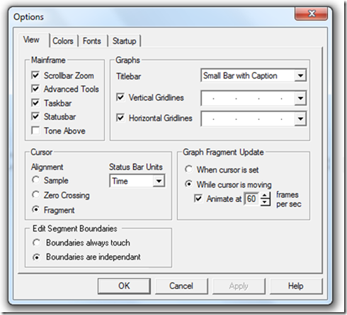

3) There needs to be a way to easily Import the numbers and Gloss words from a blank Word List.
I'll talk about this in a future email.

Find and Replace
There is a second change that needs to be done to Find & Replace.
This is needed to help users who are using Phonology Assistant.
Currently PA allows users to search and sort data, to assist in the analysis of Phonetic data, but by design PA does not make changes to the data. Therefore SA need to be able to make changes to the data based on information learned by using PA.

The current Replace function is ‘simple’ in that it does a one for one replacement (that is after you make the change that allows a single letter to be replaced in a word e.g. bat --> cat). What is needed is a Replace that is context sensitive. There are two levels of complexity, for now we will use the ‘simple complexity’ concept later on we may need to use ‘complex complexity’ concept (how’s that for grammatical miss-use).

The dialog box needs to have a place to let the user ‘built’ a ‘simple’ environment in which to do the Find/ Replace. If this is left blank then all of the Find items will be replaced regardless of it’s environment.

The environment consists of ‘limiting’ the places where the Replace is done. Thus the matching of the Find needs to be sensitive to it’s neighbors.

For example:
Find: a
Replace: e
Data: bit bat but bay

Results: bit bet but bey

But if there is an ‘environmental’ constraint like: “Only do the Replace if the letter after the Find is a ‘t’ ”.

New Results: bit bet but bay

The way this kind of rule is written in Phonology is: a –> e / __t

That means “Change all ‘a’ to ‘e’ IN THE ENVIROMENT OF ’a’ preceeding ‘t’

There is a special character known as Word Boundary and is the pound symbol
‘ # ‘

Thus this Rule: a –> e / __#
Means “Change ‘a’ to ‘e’ IN THE ENVIROMENT OF ‘a’ is at the End of a word.

Thus this Rule: a –> e / #__
Means “Change ‘a’ to ‘e’ IN THE ENVIROMENT OF ‘a’ is at the Beginning of a word.

Thus this Rule: a –> e / #__t
Means “Change ‘a’ to ‘e’ IN THE ENVIROMENT OF ‘a’ is at the Beginning of a word AND preceding a ‘t’

For the new dialog box the Rule: edit control can be pre filled with the text of Find, the arrow –>, the text of Replace, the Environment marker / , and then let people enter what they want which will be one or two letters or the change in a pitch number. You could prefill the two underscore characters and place cursor AFTER them (since it is common to look for FIND and then care about the item that FOLLOW it, thus the most likely thing a user will want to add is a character after the __

There are three common things a user might put in the environment (things to the right of / )

Word Boundary: #
Any Consonant: C
Any Vowel: V

So things like this are common:

ɜ –> ə / __ C#
ɜ –> ə / #C __
ɜ –> ə / __ VC

The values of V are found on the Find and Replace dialog box IPA Chart, Vowels tab.
The values of C are found on the Find and Replace dialog box IPA Chart, Consonants tab and Diacritics tab.

I assume the SA source code for the IPA Chart has either the characters or their code points.

So a common thing might be:

t –> tʰ / #s__

Data: start
Result: stʰart

I think what is needed in order to do the search is:

1) If the environment is “# __” then find all of the word initial words that have the Find item

2) If the environment is “__ #” then find all of the word final words that have the Find item

3) If the environment is “some consonant __ some vowel” then find all of the words that have the string “some consonant+Find+some vowel” (i.e. Find: ‘e’ in the environment of ‘s __ a’ then look through the words and find
‘...sea...’; seat, unseat, research,...)

4) if the environment uses C or V then build a list of words that consists of the Find item with all of the C’s from the Consonants and Diacritics chart or all of the V’s from the Vowel chart. Then look for that string in the words.

BTW, another idea I have is, if you want to protect the environment string, then you might build the text control like this:

or maybe best is like this:

If you have any questions, then let me know.
It would be fine to implement the Environment field in one version of SA, and put the C and V support in a second version of SA.

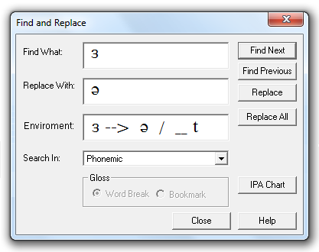
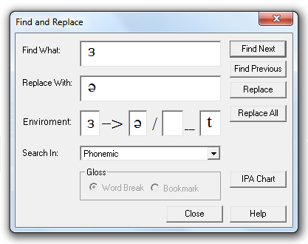
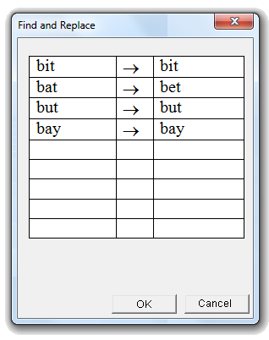

The use of SA directly with PA has over taken the idea of SA putting data into FLEx for the moment, although that will need to be done after the user finishes the SA/PA analysis work.

After doing the work to provide support for Environmental Find and Replace, and after C and V are supported, then the following is needed to confirm that what the user is thinking will happen.

That is the dialog box needs a new button for “Test”:

The result of pressing the “Test” button is to show the user what would happen if they used the current Environment based Find and Replace:

Pressing Ok would make the changes and close both dialog boxes.
Pressing Cancel would close this dialog box and enable the user to build a new environment.

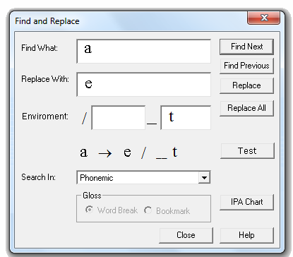
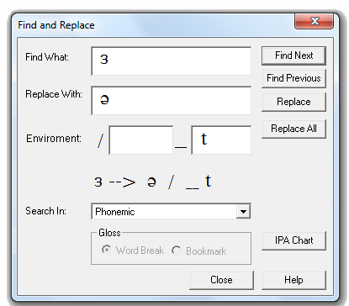

-----------------------------------------------------------------------
11/30/2011

I want to amend the work below when you get to it to not do the C & V work yet, but do all other things listed there including supporting the Word Boundary: # symbol, and any IPA symbol.

I’m concerned that the CV work and it’s testing will take too long to do, since the Split File work is more important than improving the Phonology Find & Replace function.

Also, I’m not sure the “Find Previous” button is needed, if the search is done from the beginning to the end. So I think just remove it from the dialog.

Automatic Transcription

11/24/11 - Transcription Setup with Phrase-Level
In the original emails, it shows that Phrase Lists should also be on the TAT dialog box. Is this still true?
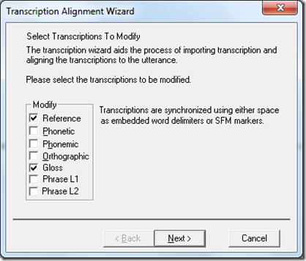
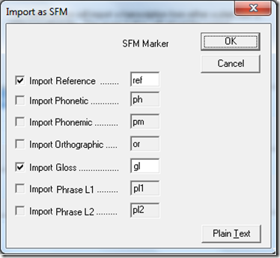

11/19/12 – Preview Button
I would like to have a small update to TAT. I’m spending a lot of time re-entering data and options in TAT as I test things. I really like the “Preview” option you made in the “Locate...” dialogs, so would you do that here also.
On the next to last TAT page:
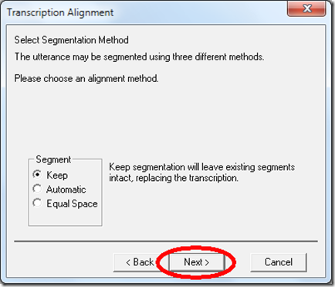
Would you rename the “Next” button to “Preview:
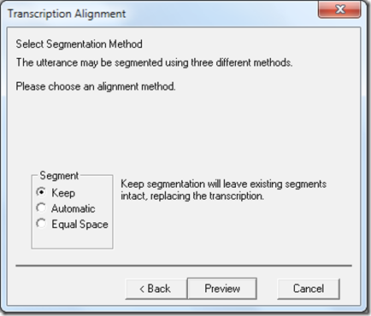
and then do the action of what happens when a user would click “Finish”:
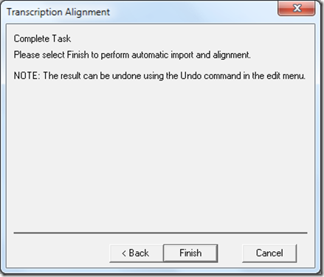
and then show the last page.
If the user clicks Finish here on the last page, then just close the dialog box and keep what is shown in SA.
If the user presses “Back” at this point, then do an Undo command and go back to the previous page.
Also, the text at the top of this dialog, should be changed from:
“Please select Finish to perform automatic import and alignment.”
to
“Please select Finish to complete automatic import and alignment.”

11/20/12 – Multi-font Grid Control
Attachments: 436 Wordlist for testing SA.docx; MSEA 436 Gloss only.txt; 436 Wordlist for testing SA.txt
I’ve done some testing of TAT and it seems to work fine. I am ok with Ph, Pm and Or just using <space> as a delimiter and # for words. Attached is a Gloss Only file for testing. I would expect this to be used by students in their class work.
I have also thought about an improved way for TAT to work. My idea was to use a grid to show the data in each of the 4 edit windows. That would allow IPA transcriptions with two words to work correctly, and # would not be needed for Gloss data.
But then I thought why not have a new view of the data, where all 4 data sets were shown at the same time. But the problem is it would have to be a multi-font edit control. The Grid could show the data in either Vertical or Horizontal orientation. This is nice to have someday idea, it’s not needed now, since the current use is for students and the 436 list.
However I would like to be able to import completed wordlist from several other languages. This would be a feature that I only know about, and not for users here at this time. I’ve attached a Word and Text version of a Thai wordlist file that uses Tabs to delimit the data. In the case where there are two Tabs in row, with nothing between then, then there is a blank column (this is the case for Phonemic). After SA process the file, I don’t need to see it in the text window. This feature can be put in the Gloss Import location and when any file is opened then test the first data item. If it’s a number, then it’s a Gloss wordlist for classroom use, or if it’s Ref, then that would indicate it is a special file with multiple columns. Let me know how much work it would be to add this multi-column import, before you work on it.

11/22/12 – Design – revision
I’ve looked at the various options and made comments about them below.
Everything seems to work correctly.
Currently, if Keep is selected (which is the default) and there is no segmentation in the file, then SA will use Automatic, and then place the users data.
Since Keep is actually not a valid choice when there is not existing segmentation, I suggest that that you gray-out Keep and select Automatic.
====================
TAT Design
Select data type(s)
Phonetic, Phonemic, Ortho, Gloss
Edit transcription Data
- . Revise existing data as shown in the edit window.
- . Hand enter data or paste data into the edit window.
- . Import a file containing data.
Specify how to align this data
- . None - Space will not used for aligning the data, the entire data string will be considered to be a single item.
- . Word - Align the data on Word boundaries using <space> in the Phonetic transcription and # in a Gloss transcription.
- . Character - Used mostly for aligning Phonetic data so that diacritic marks are not considered to be a standalone character. This option can be used for all data types, and is thus it is the Recommended alignment option.
Specify how to segment this data
- . Keep - Use the existing segmentation. If there is none, then use the "Locate Words" process first, then place the data.
- . Automatic - Use the "Locate Phonetic Segments" first and then the "Locate Words" process, then fill these place holders with data in a sequential manner.
- . Equal Spaces - First the "Locate Words" process is used, then second each Word segment is divided into equal phonetic segments, and then phonetic data is sequential placed in these place holders.

8/15/12 Re: sa 3.0.1.11c
I've also talked with our PhD Phonetician here, who helps many users, and I have some suggestions.

This process of using stereo files needs to be made simple for national workers.
To them a file is a file. All they want is a usable file, and they don"t care how SA deals with stereo.
But there are advanced users who like select options.

So my suggestion is to show a single dialog box when SA opens a stereo file.
See attached file.

From your write-up below:

if the input file is a 'non-standard' wave file (anything other than 8/16 bit, non-PCM, encoded or multichannel) then {

Does non-PCM mean MP3 or are there other formats that SA can handle?
What is encoded? ADPCM?
Note: Compress files like ADPCM are so highly compressed that there is little usable data left for SA to use. They should not be opened.
SA is designed to use PCM wave file, Encoded formats throw away sample to shrink the file size which makes the data unusable. Thus SA is designed to not accept Encoded file; thus forcing users to record at the only acceptable format.
Note: most original MP3 files are so highly compressed that there is little usable data left for SA to use. Thus we discourage use of MP3. If however the bit rate is 128 or above it may be usable.
The real advantage of MP3 is to allow users to save their Wav data in MP3 format for use on a handheld device for language learning.
I hope SA does not get an 8-bit file; it results in an unusable Spectrogram.

Note: Although SA could open encoded formats it results in poor to unusable data analysis in SA. So to protect ourselves we tend to say SA only uses linear PCM Wav files. But to be user friendly we do support things like MP3 and we could support other encoded formats, but we would need to have a big yellow dialog box saying this may result in inaccurate results. Encoding usually means throw away data to make the file smaller. So there is no way for SA to regain what is not there due to compression.

What does SA do when a 96KHz 24bit file is opened?
Can the signal processing routines in SA handle real 96KHz signals, or only up to 44KHz? or 48KHz?
Can the signal processing routines in SA handle real 24bit data, or only 16bit data?

I"ll send some audio recording about 96-24.
*- the software runs the file through the wave resample class to convert it to 16-bit 22khz. it makes a copy. editing will automatically be allowed.

It"s my opinion that it would be better to not downgrade a 16bit 44KHz file to 22KHz.
We talk about 22KHz since that is the absolute minimum; the Nyquist is 11KHz, and that "s the range of the human voice.
In SA we should remove the 8bit recording option (it was used for compatibility with old audio hardware many years ago).
In SA we should also remove the 11KHz option, since it produces very poor analysis results (also a hold over from years ago).

- if the wave re-sampler determines that the file is multi-channel then {
- the software will ask the user which channel they want to use, or if they want to merge all channels.

This is the part where a novice user does not know what to do.
Note: SA should always use the Left channel for mono, that is the industry definition of mono.

- the software will create a version based on the user selection. it will be a copy, where editing will be allowed.

I agree make a new file, but change the name for the user; using the old filename and appending the word mono

}
} else {
if the file is a 'standard' wave file (non encoded 8/16 bit 22khz, but allowing multi channel)
- the software will tell the user and ask them if they wish to make a copy (editable) or work with the original (non editable).

I believe that any file opened by SA should always be made editable; you never know when they need to edit it.

- if they select 'make a copy' then {
-the software will run the wave file through the wave re-sampler (up above *)
} else {
- if the code determines that the file is multi channel then {
- the software will ask the user which channel they want to use (merging is not allowed).
- the software will create a version based on the user selection. it is not a copy, editing will not be allowed.
}
}
}

Users can select Advanced Options if they want to use the Right channel or Merge the channels.

If a user had two separated microphones and determined the Right channel was better, then a user might want this option.

But we would never want to use a Merge of L+R for linguistic analysis. This process will introduce echo and make file unusable.
It"s ok to have this option, but it "s not practical for our use. Maybe the Music people would want it.

if it's a mono file, none of the dialogs should show up.

I agree.

From: kgorham
Sent: August 08, 2012 12:02 PM
To: Terry Gibbs
Subject: sa 3.0.1.11c
Hi Terry,

Attached is a copy of MSEA SA with the new dialogs.
There is a unresolved issue in this version, so I wouldn't release it to customers yet until it's fixed.

The change has been made in a couple places:

if the input file is a 'non-standard' wave file (anything other than 8/16 bit, non-PCM, encoded or multichannel) then {
*- the software runs the file through the wave resample class to convert it to 16-bit 22khz. it makes a copy. editing will automatically be allowed.
- if the wave resampler determines that the file is multi-channel then {
- the software will ask the user which channel they want to use, or if they want to merge all channels.
- the software will create a version based on the user selection. it will be a copy, where editing will be allowed.
}
} else {
if the file is a 'standard' wave file (non encoded 8/16 bit 22khz, but allowing multi channel)
- the software will tell the user and ask them if they wish to make a copy (editable) or work with the original (non editable).
- if they select 'make a copy' then {
-the software will run the wave file through the wave resampler (up above *)
} else {
- if the code deterrmines that the file is multi channel then {
- the software will ask the user which channel they want to use (merging is not allowed).
- the software will create a version based on the user selection. it is not a copy, editing will not be allowed.
}
}
}

if it's a mono file, none of the dialogs should show up.

The code for the 'non-standard wave already existed (96khz feature), but the selection of the channel is new.
The code for the 'standard' wave file was the preexisting code that you mentioned in your email (left channel only).
This code was modified to specify making a copy or not, and selecting a channel.

The problem I am experiencing is:
1) When we create a 'copy' the file name stays the same. This is somewhat confusing, and it prevents me from reopening the file and selecting another channel.
2) When we don't create a copy of the file, the file name stays the same, and it really isn't evident what I'm looking at anymore. If I close SA, it reopens the file on startup, and the 'make copy' dialog blocks behind the splash screen.
It seems like there needs to be an indicator on the window, or the filename needs to change.
Please play with this version, and let me know of any feedback.

10/29/12 – Background Artifacts
Kent,
SA 3.01 had background artifacts when the waveform was zoomed-in and panned left or right.
This was fixed in the MSEA version. I thought this bug was fixed in the 3.1 release, but I just noticed it’s not fixed.
Am I missing something?
Terry
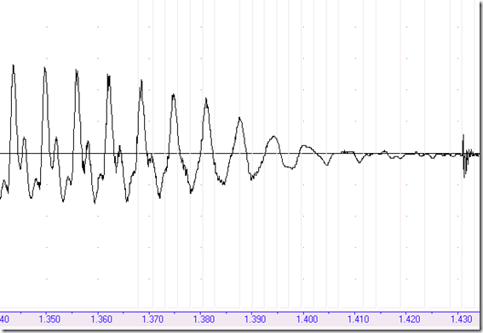

11/2/12 – Copy Transcription

Kent,
This new feature is needed so that other programs can take the Phonemic result and work on the Orthography.
Thus there needs to be a new item on the Edit menu called “Copy Transcription...”
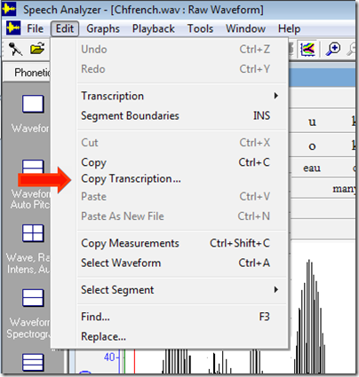
And when it is selecting, then should show the dialog box like this:
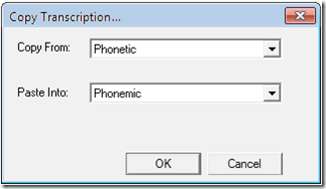
Someday we may add additional source and destination transcription fields.
Terry

11/5/12 – Reference Data
In main menu “Tools/ Automatic Markup” sub-menu list, would you change “Reference Data” to “Add Reference Numbers”, and change the “Reference Data” dialog box title bar name to “Reference Numbers”.
,
In an effort to deal with problems in numbering wordlists, there needs to be a way to start in the middle of a file and number from there to the end of the file. Would you revise the current Reference Data dialog box on the left to look like the one on the right?
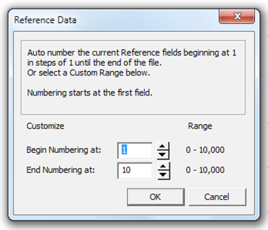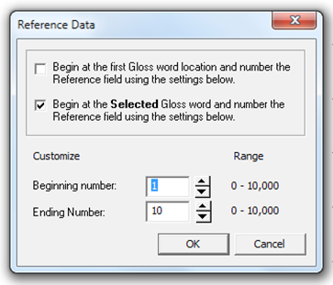
Note I also made the wire frame around the text less tall by raising the bottom edge so the space from the top edge to the first sentence and the bottom edge to the last sentence be the same. I also changed the Customize labels, so that there is no confusion about these setting referring to the actual location of the gloss work.
Oh, by the way, when a user runs this process, then the Ref transcription field needs to be showing, so I suggest that when the user presses OK that you first make sure the Ref field is showing.

11/28/12 – Excel Export Option
A PhD linguist here has asked that SA provide an Export option that could be used in Excel and in Word.
I’ve considered the idea of having an export with a choice of Rows or Columns and Tabs or Space,
but I’ve found that a doing Columns and Tabs export will satisfy nearly all possible needs. So would you,
at some point (maybe in January), include a new “Data in Columns Format” option:
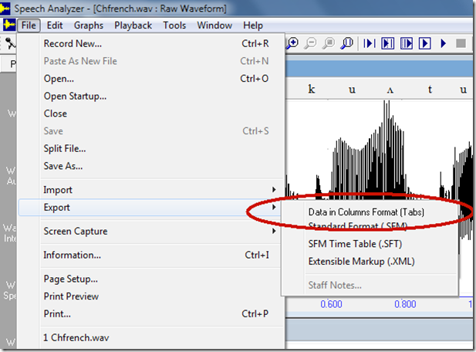
The Columns Format data in a tabbed delimited text file called “ChFrench.wav.txt” would look like this:
Ref | Phonetic | Phonemic | Ortho | Gloss
1 | m | m | m | thanks
 | ɛ | ɛ | e
 | ʁ | ʁ | r
 | s | s | c
 | i | i | i
2 | b | b | b | many
 | u | o | eau
 | k | k | c
 | u | u | oup
3 | ʌ | a | à | to
4 | t | t | t | all
 | u | u | ous
5 | l | l | l | the
 | e | e | e
 | z | z | s
6 | æ | a | a | friends
 | m | m | m
 | i | i | is
7 | k | k | qu | who
 | i | i | i
8 | s | s | s | are
 | ɒ̃ | ɒ̃ | on
 | t | t | t
9 | i | i | i | here
 | s | s | c
 | i | i | i
10 | o | o | au | today
 | ʒ | ʒ | j
 | o | u | ou
 | ʁ | ʁ | r
 | d | d | d'
 | y | ɥ | hu
 | i | i | i
or like this if, ChFrench did not have segmental phonetics:
Ref | Phonetic | Phonemic | Ortho | Gloss
1 | mɛʁsi | mɛʁsi | merci | thanks
2 | buku | boku | beaucoup | many
3 | ʌ | a | à | to
4 | tu | tu | tous | all
5 | lez | lez | les | the
6 | æmi | ami | amis | friends
7 | ki | ki | quis | who
8 | sɒ̃t | sɒ̃t | sont | are
9 | isi | isi | ici | here
10 | oʒoʁdyi | oʒoʁdyi | aujourd'hui | today

11/12/12 – Record and Overlay Demo
In the main menu item:
Graphs/ Overlay/ Record Overlay
(which is also the last button on the Tool Bar), there is some code in SA that prevents specific windows from being updated. Typically a user will only have Raw Waveform and Auto Pitch open when using Record Overlay. SA specifically excludes updating the data in the Spectrogram, Spectrum and Formant Charts (e.g.. F2-F1). Alec did this because when SA was designed CPU’s were not fast enough to calculate the data.
I would like to do a test on my machine, so would you change the code to allow Formant Charts to be updated?
If this works I want to show this feature at a special Thai Phonetics Seminar that the Linguist Department is hosting this Saturday.
Would you be able to make this change and include it in 1.15 for me to try out by Friday?
BTW, If you open a short file (maybe make a new file, say the word “tree” and Save it) and then show Waveform and F2-F1 and make that windows small, then when you use Record Overlay you can see the temp file that is created and see the data for Waveform and F2-F1. The issue is that for the F2-F1 chart, is that it is not being updated.
If you had shown Waveform and Spectrogram, then when you use Record Overlay you can see the temp file and see the data for Waveform and Spectrogram. There would not be much value showing the new Spectrogram, but showing the new ‘Orange’ Formant Tracks overlaid on the open Spectrogram window would show the user how far they are off in Formant space. I don’t want you to spend the time to do this work now for the Spectrogram. Just see if you can update the F2-F1 chart and thus allow users to see the original Blue dot and the new Orange dot.

11/12/12 – 12/14/12 – Wordlist Automation
As I work out the steps for marking up a recording, I plan to send you on-going revisions as I refine my thinking of the process.
So this is #1, in which I will give the general process. Towards the end of all of this I hope we can use a Wordlist Automation Tool.
#1
Given a recording of one Word from the MSEA Wordlist, then:
The Leader has the Wordlist and is asking the Helper, who know the National Language of the country, to say the word in his Village Language.
The audio proceed like this:
Leader: Word number X, Word in English, Word in National Language of the country.
Helper: Word in the Village Language, Word in the Village Language, Word in the Village Language.
For the 436 Wordlist in SDL recording I sent you:
The wordlist begins as:
Leader: Number 1, Sky, Mu-gong-gi
Helper: Moh-ku, Moh-ku, Moh-ku

Mark-up of the audio happen by the User of SA placing the Begin cursor somewhere before the the audio of “Number 1” and the End cursor somewhere to the right of that.

The steps the User needs do are:
1.Place the Begin cursor.
Select: Playback/ Entire File
2.After the Blue playback cursor passes the word Number, the User needs to click the left-mouse button just before the beginning of Number.
3.Then the User needs to Select: Edit/Transcription/ Add Gloss Word Segment (i.e. Ctrl+w), and this will place a # Gloss marker at that location and adds a Phonetic segment above it.
4.The Blue playback cursor is still moving and as it passes the first word spoken by the Helper, then the User needs to click the left-mouse button just before the beginning of the first Village Language word.
Then the User Selects: Edit/Transcription/ Add Gloss Word Segment (Ctrl+w), and this places a # Gloss marker at that location and adds a Phonetic segment above it.
5.The Blue playback cursor is still moving and as it passes the third word spoken by the Helper, then the User clicks the left-mouse button just after the last Village Language word.
Then the User Selects: Edit/Transcription/ Add Gloss Word Segment (i.e. Ctrl+w), and this places a # marker at that location,
and adds a Phonetic segment above it.
6.Then when the User hears the production of the first word spoken by the Helper, then the User clicks the left-mouse button just before the beginning of the Village Language word.
Then the User Selects: Edit/Transcription/ Add Gloss Word Segment, and this places a # marker at that location and adds a Phonetic segment above it.
7.
And so on, and so on, placing markers just before and just after the three Village Language words.
Note that placing the cursor at the end of the third Village Language word and selecting Ctrl+w does two things, it marks the last Village Language word, and it marks the beginning of the next Number X spoken by the Leader.
As a test, you can select Playback/ Player and set set the speed to 70%, and zoom in on the DSL recording and try this process yourself.
------------------------------------------------------
The User steps below are just the same as in Mark-up #1, but I’ve added the marking of Phrase data.
1.Place the Begin cursor.
Select: Playback/ Entire File
2.After the Blue playback cursor passes the word Number, the User needs to click the left-mouse button just before the beginning of Number.
3.Then the User needs to Select: Edit/Transcription/ Add Gloss Word Segment (i.e. Ctrl+w), and this will place a # Gloss marker at that location and adds a Phonetic segment above it.
4.The Blue playback cursor is still moving and as it passes the first word spoken by the Helper, then the User needs to click the left-mouse button just before the beginning of the first Village Language word.
Then the User Selects: Edit/Transcription/ Add Gloss Word Segment (Ctrl+w), and this places a # Gloss marker at that location and adds a Phonetic segment above it.
5.The Blue playback cursor is still moving and as it passes the third word spoken by the Helper, then the User clicks the left-mouse button just after the last Village Language word.
Then the User Selects: Edit/Transcription/ Add Gloss Word Segment (Ctrl+w), and this places a # marker at that location,
and adds a Phonetic segment above it.
The user then User Selects: Edit/Transcription/ Add Phrase L2 Segment (Ctrl+2).
Then User then needs to Select: Edit/ Select Segment/ Up Item (Alt+Up-Arrow) three times and then Edit/ Select Segment/ Previous Item (Alt+Left-Arrow) once, then Selects: Edit/ Cut (Ctrl+X), and then Selects: Edit/Transcription/ Add Phrase L1 Segment
Then User then needs to Select: Edit/ Select Segment/ Next Item (Alt+Right-Arrow) once, and then Edit/ Select Segment/ Up Item (Alt+Up-Arrow) once, and then Select: Edit/ Select Segment/ Next Item (Alt+Right-Arrow) two times.
6.Then when the User hears the production of the first word spoken by the Helper, then the User clicks the left-mouse button just before the beginning of the Village Language word.
Then the User Selects: Edit/Transcription/ Add Gloss Word Segment, and this places a # marker at that location and adds a Phonetic segment above it.
7.The Blue playback cursor is still moving and as it passes the third word spoken by the Helper, then the User clicks the left-mouse button just after the last Village Language word.
Then the User Selects: Edit/Transcription/ Add Gloss Word Segment (Ctrl+w), and this places a # marker at that location,
and adds a Phonetic segment above it.
8.Jump back to step #5 until the end of the file.

The problem is there is not enough time to do all of the mark-up in #5 and keep up with the moving Playback cursor.
And that’s why an automation tool is needed.
It needs to trigger on marking the end of the production of the three words and do all of the Phrase mark up automatically, so the user can be ready to mark the beginning of the next group of three Village Language words.
------------------------------------------------------
Everything is the same as in the previous Wordlist Mark-up #2 email, except one more thing needs to be done in step #5.
That is the, Duration of PhraseLevel=”1”, needs to be dynamically revised so that it’s new value includes the Duration of it’s related PhraseLevel=”2” component.
So using this .saxml snip as an example:
<MusicSegments>
<MusicSegmentData PhraseLevel="1" Offset="14.092448979591836" Duration="3.7696598639455781">
<Annotation>�</Annotation>
</MusicSegmentData>
</MusicSegmentData>
<MusicSegmentData PhraseLevel="2" Offset="17.862131519274378" Duration="3.0894557823129252">
<Annotation>�</Annotation>
</MusicSegments>
The end of Phrase Level 1 is currently aligned to the beginning of Phrase Level 2 because of the way we are doing mark-up.
Which is what is needed.
So all we need to do is add the Duration of PhraseLevel="2" to the current Duration of PhraseLevel="1".
Thus from above, the Duration of PL2 is added to the Duration of PL1, so that PL1 also ends at the same position as PL2 ends.
i.e.
3.7696598639455781 + 3.0894557823129252 = 6.8591156462585033
Thus the .saxml would look like this:
<MusicSegments>
<MusicSegmentData PhraseLevel="1" Offset="14.092448979591836" Duration="6.8591156462585033">
<Annotation>�</Annotation>
</MusicSegmentData>
</MusicSegmentData>
<MusicSegmentData PhraseLevel="2" Offset="17.862131519274378" Duration="3.0894557823129252">
<Annotation>�</Annotation>
</MusicSegments>
This of course needs to be done inside of SA so that numbers are correct and the segment are updated.
I am using the .saxml view of the data to explain what is needed.
Does make sense?
Doing this will enable PL1 to be the complete production of each Wordlist Word:
Leader: Word number X, Word in English, Word in National Language of the country.
Helper: Word in the Village Language, Word in the Village Language, Word in the Village Language.
And PL2 will be the sub-set:
Helper: Word in the Village Language, Word in the Village Language, Word in the Village Language.
------------------------------------------------------
There is no way for SA to know then the end of a set of three words is spoken and thus trigger the complex activity needed in step #5.
Thus I see the need for a Wordlist Automation Tool.
Once started it would keep track of the Begin and End of the Village Language words and do the #5 work in the background.
The other thing that seems useful for Users is to not have to press Ctrl+w since it is a bit awkward, so I think it would be unique to use the Space bar to act as the add Word Gloss Segment only when using this tool.
So once the Wordlist Automation Tool is selected, a dialog box would be shown that has Start button that when pressed would begins playback. Then pressing the Space bar would move the Begin cursor the the current Playback location and do a Ctrl+w, that begins the mark-up.
After that pressing the Space bar happens at the beginning and end of the three Village Language Words.
The last thing is that the Automation Tool needs to know that the Playback cursor is about to go out of view to the right side of the screen and thus a Pan Left (a Horizontal scroll) is needed to keep the Blue Playback cursor in view.
A refinement of this is to just pin the Blue cursor 25% left of center on the screen and move the Raw Waveform to the left.
Assuming that’s possible.

11/26/12 – Larger SDL Test File
I previously sent the SDL file that had the first ten words of a MSEA 436 Wordlist recording session.
When you’ve finished most of work on Split File and TAT, we can begin to use that file for testing those new feature.
But since it is only 10 words from a 436 word list, I thought we should eventually use a larger portion of that recording session to see how SA handles more data. I’ve therefore taken the first 50 words and divided it into 4 files which I will send. I suggest that you open all 4 files in SA and then Copy and Paste the other three in order into the 1-12 file and thus rebuild a single 1-50 file.

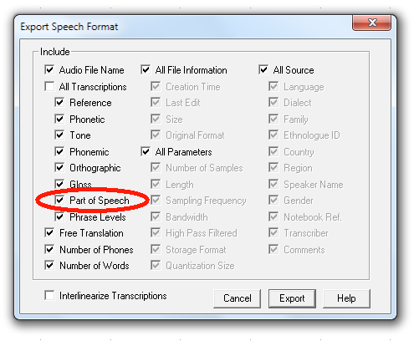
12/21/12 – other methods
There are other techniques that SA could use to mark up the recording.
Given the 436 Wordlist, we can expect 4 recording of about 100 each or 8 recordings of about 50 each.
Method #2:
As the User marks the locations of the Beginning and Ending locations of the meta data of Leader and the three Village Language words, an obvious pattern is being built up. That is an on-going set of number of the lengths of PL1 and PL2. That is, an average of what to expect for the location of the next Word and the location of the Village Language words within that Word.
If we have a 50 or 100 Words, then after 10 or 20 Words, a reasonable average of PL1 and PL2 can be calculated.
At that point SA could just mark-up the rest of the file and let the User adjust the inaccurate positions of the markers.
Thus the user does not have to do all the work of marking each Word.
Method #3:
The user can do even less work, by not marking the Leader meta data and not marking PL1.
So what the user does is just mark the Beginning and the End of the three Village Language words. And if SA can get a good estimate of the timing between the Begin locations and the length of the three words, then SA can auto-locate just those words. Even PL2 can be left unmarked.

12/22/12 – Word Selection
The next step after the recording is marked-up is for the User to identify one on the three Village Language Words as the ‘best’ one of the three by listening to each on of them and then moving the Begin and End Phonetic boundaries that currently define the three words to only define one of them.
About the only thing we can do is help with playback and then getting to the next set of three Village Language Words.
So the steps are:
Select: the first Phonetic segment in the recording, then
Select: Segment Size
Select: Playback/ Player (set to Play: Between Cursors)
...begin loop...
Select: Play
The User uses the mouse to move the Begin and End cursors to select the ‘best’ production of a Word.
The User selects Edit/ Select Segment/ Next Item.
... jump to begin...
This continues until the end of the file.
There is a choice the user can make each time they have selected the ‘best’ word:
1) they can either continue on to the next set of three words
2) they can click on the selected Word and enter the IPA transcription.
This is really up to the users preference, and what they want to do at the particular moment in time. Having listened to the three words, they already have in mind what the phonetic content is of those three words and specifically the one ‘best’ word and may well be ready to enter what they feel is an accurate IPA transcription.
Or they may just be in to mood to go through the file and get the ‘best’ words selected and then on the next pass through the file enter the IPA.
The challenge for us is showing the Translation Editor if they do want to enter the IPA.
So what is really needed is a combination of some of the features in Player and TE, we also at this point need PL2, so in the previous mark-up stage of processing we need to always mark PL2.
So what the user needs is a new dialog that can:
1) jump to the next PL2 segment
2) auto play PL2 twice (slowed down if needed)
3) allow the user to enter IPA in the Phonetic Segment (if they want to)
4) wait until step #1

12/22/12 - Wordlist Data
Once the user has marked up the file, and SA has a string of Words (Village Language Words and PL2’s), then it’s time to ask for the Wordlist file so we can enter the Ref and Gloss data, and thus ensure at this early stage that the work the User is doing is on the correct data set.
So first show Tools/ Automatic Markup/ Add Reference Numbers dialog, and let the user Import the Wordlist,
then the Tools/ Automatic Markup/ Align Transcription Data dialog, and preselect “Use Ref Data to Import Transcriptions”, Modify: Ref, Modify Gloss, press the Next key, disable the Import button, and basically just let them see the Wordlist and they need to press Next and Finish.
Terry

12/22/12 – Processing Steps
The processing steps needed for automating markup are:
1) Markup the recording – as noted in the first two email with the Subject Wordlist Automation
2) Import the Wordlist – as noted in email Wordlist Data
3) Word Selection – as noted in email Word Selection
At this point then, the 4 or 8 files are ready to be used in PA.
Using PA will enable the User to refine their Phonetic IPA and to investigate the actual Phonemes in the language and then enter them in the Phonemic Transcription filed in SA. What the User will do is spend time correcting the Phonetic IPA until the Phonemes are fairly clear in their mind, then they will do a “Copy Phonetic to Phonemic” and then Find/ Replace in the Phonemic Transcription field to revise it to match their understanding of what is needed to make that data accurate based on their understanding of what the Phonemes are.
After Phonemic analysis is done. SA can be used to split the long recordings into small one word files for use in FieldWorks.
FYI: Phonetics is the exact IPA transcription of the acoustic events in the production of a word.
Phonemics is the generalization of the several variation of how that word is spoken such that only one set of IPA is used in all cases.
That is, the word ‘car’ is pronounced differently in New York, Georgia and California. We refer to those as ‘dialect’ difference, and if transcribed Phonetically there will be three different IPA transcriptions, but we understand that there is only one meaning for car so there is only one Phonemic transcription of car and based on those Phonemic IPA characters we have only one way we spell car. The orthography always follows the Phonemic transcription never the Phonetic when doing new linguistic work. Thus you create the alphabet of a new written language that is phonemically based.
American English is a mess since it is based on several languages: British English, German, French and Italian. For example a Chevy car is made by the Chevrolet Motor Company and we say “Chev-ro-lay” not “Chev-ro-let” since Chevrolet is French and we spell it differently than it sounds; thus American English is not Phonemically based. But all new written languages that Wycliffe creates is a writing system that is always Phonemically based. That’s because we do not need to confuse new language learners that they need to write letters in a word for which there is no sound in that word when it is spoken.
Terry

12/22/12 – Dialog boxes and markup
Now that I’ve given an somewhat detailed overview in previous Wordlist Automation email about what a User needs to do in marking up a Wordlist, I’ll begin to talk about the user interface that is needed to accomplish these tasks. I assume that I’ve not thought about every detail of every step in the previous emails, and I also assume I will not got all of the details correct in these Dialog Boxes emails I’m about to write, and not going to get things right the first time for a Wordlist Automation Tool Bar I have in mind. So anyway, all of this is an experiment which I hope will not waste too much of your programming time, but will provide a process that a novice user of SA can use without much effort as they markup a Wordlist.
I see the primary Wordlist Automation dialog box as an interface to each of the major steps in using a Wordlist:
- . Wordlist Markup
- . Data Import
- . Word Selection
- . IPA Transcription
- . Phonology
- . Fieldworks

So the initial dialog might look like:
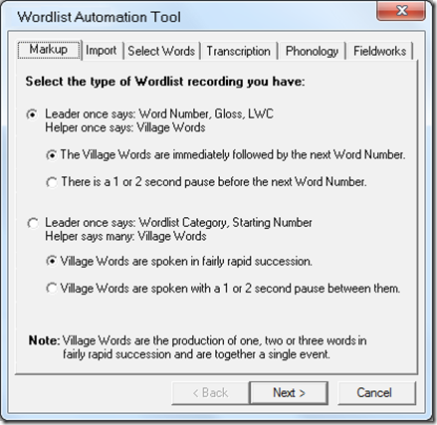
=================================================
To save you re-typing it, here is the dialog text:
Select the type of Wordlist recording you have:
Leader once says: Word Number, Gloss, LWC
Helper once says: Village Words
The Village Words are immediately followed by the next Word Number.
There is a 1 or 2 second pause before the next Word Number.
Leader once says: Wordlist Category, Starting Number
Helper says many: Village Words
Village Words are spoken in fairly rapid succession.
Village Words are spoken with a 1 or 2 second pause between them.
Note: Village Words are the production of one, two or three words in fairly rapid succession and are together a single event.

12/23/12 – Dialog Boxes – 6 more
Here are 6 more dialog box screen shots along with the text for two of them.

I still need to design the more complex:
Wordlist Automation Tool - Markup Dialog #2

It would probably make it easier to see the work flow, if you could print out each dialog to see the progression in working with the Wordlist.

I’m hoping not much code will need to be written to have this Tool work since it mostly uses existing features in SA.
The dialog boxes will take some time to design, but I hope they are not too much effort.

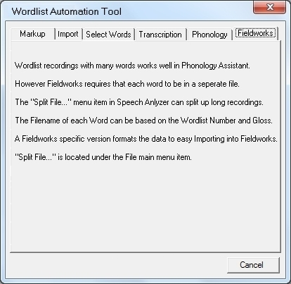
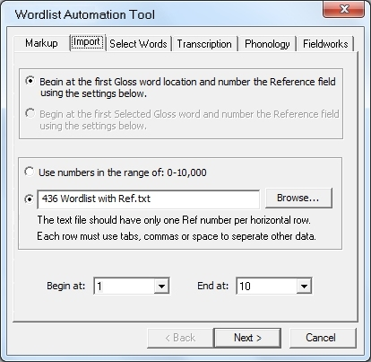
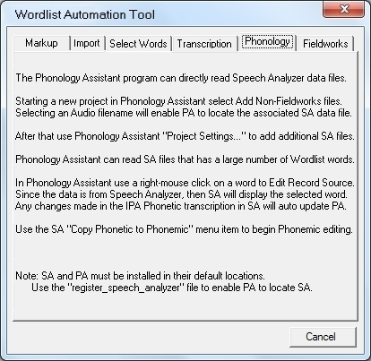

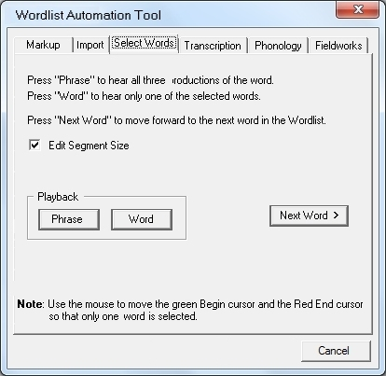
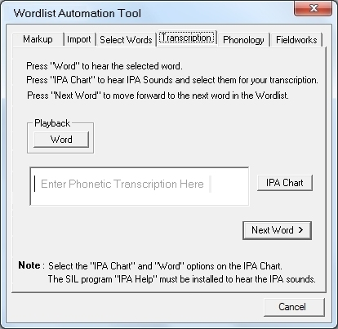

Attachment
The Phonology Assistant program can directly read Speech Analyzer data files.

Starting a new project in Phonology Assistant select Add Non-Fieldworks files.
Selecting an Audio filename will enable PA to locate the associated SA data file.

After that use Phonology Assistant "Project Settings..." to add additional SA files.

Phonology Assistant can read SA files that has a large number of Wordlist words.

In Phonology Assistant use a right-mouse click on a word to Edit Record Source.
Since the data is from Speech Analyzer, then SA will display the selected word.
Any changes made in the IPA Phonetic transcription in SA will auto update PA.

Use the SA "Copy Phonetic to Phonemic" menu item to begin Phonemic editing.

Note: SA and PA must be installed in their default locations.
Use the "register_speech_analyzer" file to enable PA to locate SA.

Attachment

Wordlist recordings with many words works well in Phonology Assistant.

However Fieldworks requires that each word to be in a seperate file.

The "Split File..." menu item in Speech Anlyzer can split up long recordings.

The Filename of each Word can be based on the Wordlist Number and Gloss.

A Fieldworks specific version formats the data to easy Importing into Fieldworks.

"Split File..." is located under the File main menu item.

12/25/12 – Dialog Boxes
As usual the Screen Shots I send you are just mock-ups that I do in a Paint Shop Pro.
What I do is take Print Screen shots of existing SA dialog boxes and revise them pixel-by-pixel to convey my ideas.

I thought if you printed them out on paper they might make more sense as what the work-flow is for working with Wordlists.

So yes I want a prototype, when you have time, so would you create this series of 7 dialogs in code, and wire-up the buttons to existing SA code.

Place the base dialog here:
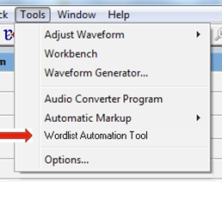
Is still have one or two dialogs to design and I also need to explain how some things need to work, but you can make up what I have done so far.

11/28/12 – Re POS Export
If I remember correctly, I asked Alec to add POS based on a linguist request.
It was put into the Export dialog, but a transcription field was never done made.
The Tone transcription field was originally intended to show tonal stick figures: / \ ^ –_ ....
Based on needs here, I would like to stop using the Tone field and provide a POS field.
Would you:
Remove “Tone” as an entry in the Export dialog, but leave “Part of Speech” where it is.
Rename the Raw, Auto Pitch, ... window labels from Tone to POS.
Rename Tools/ Options/ View/ Mainframe “Tone Above” to “POS Above”
Move the POS transcription bar to be below Gloss, but allow it to be moved via “POS Above” Gloss.
Re-work the code so that the structure of this POS field is Gloss Word based instead of being Phonetic Segment based.
I thinks that’s it.
This work can wait until after the Split File work, and other current e-mail have been worked on. So maybe in January.

12/21/12 – Language Auto Selection
How much work is needed to change SA so that it Auto Selects the Language Icelandic, and thus the IPA keyboard, when a user selects a segment in the Phonetic or Phonemic transcription fields?

BUGS

[SPA-481] Cannot open 24-bit WAV files Created: 15/Aug/11 Updated: 15/Aug/11
Status: | Open
Project: | Speech Analyzer
Component/s: | Player
Affects Version/s: | 3.0.1
Fix Version/s: | None

Type: |  | Bug | Priority: | Critical
Reporter: |  | John Wickberg | Assignee: | Unassigned
Resolution: |  | Unresolved | Votes: | 0
Labels: | None
Remaining Estimate: | Not Specified
Time Spent: | Not Specified
Original Estimate: | Not Specified
Environment: | Reported by Mike Cahill

Description

Many current recorders create 24-bit WAV files and these can't be opened directly in SA.
Since Windows Media Player is used to do the conversion of sound files that aren't 16-bit or 8-bit WAV files, the problem may with WMP.

[SPA-474] Settings files not getting written Created: 11/Jun/10 Updated: 11/Jun/10
Status: | Open
Project: | Speech Analyzer
Component/s: | Graphs - Parameters
Affects Version/s: | 3.0.1
Fix Version/s: | None

Type: |  | Bug | Priority: | Critical
Reporter: |  | Steve White | Assignee: | Unassigned
Resolution: |  | Unresolved | Votes: | 0
Labels: | None
Remaining Estimate: | Not Specified
Time Spent: | Not Specified
Original Estimate: | Not Specified
Environment: | Windows 7 Starter, WIndows XP

Description

A user finds that the custom graph types cannot be saved, he also cannot get rid of the initial warning message about XML files. The program is not writing .psa files in the <My Documents>\Speech Analyzer folder and he has permissions to write to that folder.
"I am not found the file [g-speech.psa] in the Libraries\Documents\Speech Analyzer in
Windows 7 and in C:\Documents and Settings\1\My docs\Speech Analyzer
in Win XP Sp3. And any *.psa file in all comp (I have seached in hiden
system files too). I have permission to write (as Administrator).
Our soft: SA 3.0.1
Win XP Pro SP3 and Win 7 Startup"
Bert Jickty <bertjickty@gmail.com>
Initial request:
From: Bert Jickty [mailto:bertjickty@yandex.ru]
Hello from Siberia!
I am engineer at the Yakutian State University. And I have problem with Speech Analyzer.
It's not save custom configuration of Graphs and Layouts permamently by: Tools-Options-Startup-Permanently-Close. If i create new configuration (F7) and save and reload SA, default graphs configurations only is appear.
And secondly: how disappear startup message about .saxml files?
Our soft: SA 3.0.1
Win XP Pro SP3 and Win 7 Startup"

[SPA-473] Unaable to install SA on Windows 7 - 64-bit Created: 09/Mar/10 Updated: 09/Mar/10
Status: | Open
Project: | Speech Analyzer
Component/s: | None
Affects Version/s: | 3.0.1
Fix Version/s: | Postponed - Next Steps

Type: |  | Bug | Priority: | Critical
Reporter: |  | John Wickberg | Assignee: | Unassigned
Resolution: |  | Unresolved | Votes: | 0
Labels: | None
Remaining Estimate: | Not Specified
Time Spent: | Not Specified
Original Estimate: | Not Specified
Environment: | Reported by "Konstantinos Avdelidis" <avdel@auth.gr>

Description

Dear madam/sir,
Well I finally managed to workaround the error described in my previous e-mail and install the Speech Analyzer 3.0.1 on my Windows 7 x64.
However, I needed to hack the "Speech Analyser.msi" installation file (hope you don't mind).
The problem lied at the fact that for some reason (I don't have THAT deep knowledge of Windows Side-By-Side registration mechanism in Windows 7) the assembly "Microsoft.VC80.CRT" (and probably "Microsoft.VC80.MFC") for version 8.0.50727.42 failed to install. I tried to modify the files and manifests to version 8.0.50727.163 which was already installed in my system but the same error with the previous version number kept coming up. So I figured that somewhere in the MSI file the version was hardcoded.
Here is what I did. I used the Orca MSI Editor and modified the version of the relative items from 8.0.50727.42 to 8.0.50727.163 in the "MsiAssemblyName" table. This actually bypasses the erroneous installation procedure and permits the installation to complete since the new version was already in my system.
I do not know if support and development of Speech Analyser is still active, but the truth is that I haven't found any other tool that meets my demands so good. I wonder if you could inform whether there is any service release planned in the near future or the Speech Analyser development is RIP.
I should also remind of a past bug that I had reported to you consisting of an issue about the messed up non-ANSI folder names stored in the registry during setup.
Please do take some time to give me the above information.
Thank you in advance.
Konstantinos A. Avdelidis
Electrical and Computer Engineer
PhD Candidate, Dept. Computer & Electrical Engineering, Aristotle University of Thessaloniki

[SPA-466] Crash when opening a wave file transcribed in a previous version Created: 12/Feb/09 Updated: 12/Feb/09
Status: | Open
Project: | Speech Analyzer
Component/s: | Transcriptions
Affects Version/s: | 3.0.1
Fix Version/s: | Postponed - Next Steps

Type: |  | Bug | Priority: | Critical
Reporter: |  | Corey Wenger | Assignee: | Unassigned
Resolution: |  | Unresolved | Votes: | 0
Labels: | None
Remaining Estimate: | Not Specified
Time Spent: | Not Specified
Original Estimate: | Not Specified

Attachments: | Chinese.SA2.wav

Description

Right click Chinese.SA2.wav (attached).
Click Open As and choose Speech Analyzer 3.0 (or later).
ERROR: SA crashes during startup.

Comments

Comment by Corey Wenger [ 12/Feb/09 08:43 AM ]
The crash happens when Speech Analyzer tries to release the splash screen in CSaApp::InitInstance().

[SPA-462] Problems with data location value on non-English windows Created: 02/Jul/08 Updated: 02/Jul/08
Status: | Open
Project: | Speech Analyzer
Component/s: | Tools Options
Affects Version/s: | 3.0.1
Fix Version/s: | Postponed - Next Steps

Type: |  | Bug | Priority: | Critical
Reporter: |  | Corey Wenger | Assignee: | Unassigned
Resolution: |  | Unresolved | Votes: | 0
Labels: | None
Remaining Estimate: | Not Specified
Time Spent: | Not Specified
Original Estimate: | Not Specified
Environment: | Greek WinXP migrated to English WinXP

Description

SA cannot find data location to update settings in sa3.psa.
Also, the data location setting was not updated upon reinstall.
----------------------------------------------------------------
E-mail from Konstantinos A. Avdelidis, 6/26/08...
Corey,
Thank you for the response,
However I managed to locate and solve the problem during the previous weekend and I was ment to report the fix to you. After discovering that the settings file was indeed the sa3.psa i noticed that it remained unchanged after the saving of settings. The HKEY_CURRENT_USER\Software\SIL\Speech Analyzer\DataLocation was also pointing to the right location. Everything seemed right.
-BUT-
Since I have a migrated winxp en setup from a winxp gr, my documents folder was named after "avdel - Έγγραφα" (greek chars). This produced a file access error in the Proccess Monitor, due to the fact that the folder name was not decoded correctly by SA, resulting in failing of save and load (obviously an encoding mismatch). I changed the my documents folder name in "avdel - My documents", uninstalled, installed the SA and the HKEY_CURRENT_USER\Software\SIL\Speech Analyzer\DataLocation was still pointing in the old location (no change after new install). After the manual change of the corresponding value in the registry, everything worked ok.
I tried to give a detailed description of the solution in order for you to be able to correct this behaviour in future versions or to provide help in similar conditions.
Thanks again for the prompt interest.
Konstantinos A. Avdelidis
Electrical and Computer Engineer, AUTH
PhD Candidate, Department of Electrical and Computer Engineering, AUTH
----- Original Message -----
From: SA Error Reporting
To: Konstantinos Avdelidis
Sent: Wednesday, June 25, 2008 7:30 PM
Subject: Re: Problem saving options
Dear Konstantinos,
You should be able to save the view settings, as you expect. Fonts, however, should be saved automatically, without clicking Permanently under Set default view template.
The fact that these two things do not work indicates a problem with the settings file. This is normally located under My Documents in a folder called Speech Analyzer. The name of the file is sa3.psa.
Please do the following:
- Using Registry Editor, verify that the following registry value exists:
HKEY_CURRENT_USER\Software\SIL\Speech Analyzer\DataLocation
If it does not exist, create it.
- If this value exists verify that it is set to ...My Documents\Speech Analyzer. If it is not, set it.
- Verify that sa3.psa exists.
- If sa3.psa exists, check if it has the read-only attribute set. If it does, clear this attribute.
- If sa3.psa exists, do the following
1. Start Speech Analyzer.
2. In the Options dialog box, change one of the fonts as you attempted to do before.
3. Exit Speech Analyzer.
4. Verify the file date on sa3.psa.
This assumes you are using Windows 2000 or XP. Folder names will differ slightly on Windows Vista.
Let me know if the problem persists.
Best Regards,
Corey Wenger
JAARS Software Development
Waxhaw, NC USA
----- Original Message -----
From: Konstantinos Avdelidis
To: SaErrors@sil.org
Sent: Sunday, June 15, 2008 10:27 AM
Subject: Problem saving options
Dear Sir/Madam,
I would like to ask a question regarding an unexplenable reaction of the Options\Startup\Permanently action. Do the options related to fonts, transcription bar appearance on selected graphs and graphs titlebar are supposed to be saved when "Set default view template" is pressed on "Permanently"? The thing is that I would like to use a specific (rather irregular) view every time I open the SA and it just refuses to store the custom view related data. Do I have to re-adjust the view setup every time I run the application or is some kind of a bug?
Thanks in advance.
PS: I also had a look under the "SOFTWARE\SIL\Speech Analyzer\Settings" registry keys and no values are stored in there under any of the root keys. Note also that I execute the program with an account with admimistrative rights.
Konstantinos A. Avdelidis
Electrical and Computer Engineer, AUTH
PhD Candidate, Department of Electrical and Computer Engineering, AUTH

Comments

Comment by Corey Wenger [ 02/Jul/08 10:37 AM ]
This is probably due to non-ASCII characters in the My Documents pathname.
There may be a non-Unicode string or function call in this code.

[SPA-460] Korean XPP - SA can't open wav file located in a desktop folder Created: 24/Apr/08 Updated: 24/Feb/09
Status: | Open
Project: | Speech Analyzer
Component/s: | None
Affects Version/s: | 3.0.1
Fix Version/s: | Postponed - Next Steps

Type: |  | Bug | Priority: | Critical
Reporter: |  | Todd Jones | Assignee: | Unassigned
Resolution: |  | Unresolved | Votes: | 0
Labels: | None
Remaining Estimate: | Not Specified
Time Spent: | Not Specified
Original Estimate: | Not Specified
Environment: | Korean XPP SP2  SA 3.0.1  PA 3.0.1 RC 11

Attachments: | Apr. 25 # 10.06.25 AM.jpg SA not open wav file.jpg

Description

A most curious thing...
SA 3.0.1 complains and gives an error msg (see attached print screen) when the user edits a Data Corpus record from a wav file located in a desktop folder. The desktop name has korean characters and SA doesn't like that. When you try to edit the save wav file but it's in a My Documents folder, everything works.
I also opened SA independently of PA and then successfully opened a wav file on the desktop???
Possible the file name hand-off from PA to SA isn't using the same code that SA uses for normally opening files?

Comments

Comment by Todd Jones [ 24/Apr/08 05:16 PM ]
Another curious thing... everything works fine in Korean VistaBus
Comment by Todd Jones [ 25/Apr/08 10:08 AM ]
This also happens in Simplified Chinese XPP. See attached screen shot.

[SPA-458] Relocate ReadMe file outside .msi file Created: 06/Feb/08 Updated: 06/Feb/08
Status: | Open
Project: | Speech Analyzer
Component/s: | None
Affects Version/s: | 3.0.1
Fix Version/s: | Postponed - Next Steps

Type: |  | Task | Priority: | Critical
Reporter: |  | Corey Wenger | Assignee: | Unassigned
Resolution: |  | Unresolved | Votes: | 0
Labels: | None
Remaining Estimate: | Not Specified
Time Spent: | Not Specified
Original Estimate: | Not Specified

[SPA-454] Lines left on graphs (painting problem) Created: 12/Dec/07 Updated: 18/Nov/08
Status: | Open
Project: | Speech Analyzer
Component/s: | None
Affects Version/s: | 3.0.1
Fix Version/s: | Postponed - Next Steps

Type: |  | Bug | Priority: | Critical
Reporter: |  | Corey Wenger | Assignee: | Unassigned
Resolution: |  | Unresolved | Votes: | 0
Labels: | None
Remaining Estimate: | Not Specified
Time Spent: | Not Specified
Original Estimate: | Not Specified

Description

Open any file in Speech Analyzer.
On the Help menu, click About Speech Analyzer.
Click OK.
Error: thin lines remain showing the outline of the About box.
This happens if any non-maximized window is placed in front of SA.

[SPA-450] Cancelling an encoding conversion causes crash Created: 28/Nov/07 Updated: 28/Nov/07
Status: | Open
Project: | Speech Analyzer
Component/s: | Transcriptions
Affects Version/s: | None
Fix Version/s: | Postponed - Next Steps

Type: |  | Bug | Priority: | Critical
Reporter: |  | Corey Wenger | Assignee: | Unassigned
Resolution: |  | Unresolved | Votes: | 0
Labels: | None
Remaining Estimate: | Not Specified
Time Spent: | Not Specified
Original Estimate: | Not Specified

Attachments: | Error message.jpg

Description

From John Wickberg...
While doing some testing on how SA 3.0.1 updates the SA 2 .WAV files, I copied one of the sample .WAV files of Speech Tools to a temp folder and one of my tests updated the file. I wanted to get back to a known spot, so I deleted the .SAXML file and the changed .WAV file and then moved the original file back to the temp folder from the SA2 sub-folder and then deleted the sub-folder.
I then double-clicked the .WAV file to start SA and when the conversion dialog comes up, I cancel it and then get the following message:
(see attached image)
If I now open the file directly in SA, it seems to open fine and I can cancel the conversion dialog.
I copied a different sample file to my temp folder, removed the read-only flag and then tried double clicking it. I get the same message as above when I cancel the dialog.
So, it looks like SA doesn't like you to cancel that dialog when you did a double click on the file to start the program.
I don't think this is a show stopper, but thought it worth documenting.
John

[SPA-447] Changing graph parameters causes crash in maximized graph Created: 13/Nov/07 Updated: 13/Nov/07
Status: | Open
Project: | Speech Analyzer
Component/s: | Graph, Duration, Graphs - Parameters
Affects Version/s: | 2.7
Fix Version/s: | Postponed - Next Steps

Type: |  | Bug | Priority: | Critical
Reporter: |  | Corey Wenger | Assignee: | Unassigned
Resolution: |  | Unresolved | Votes: | 0
Labels: | None
Remaining Estimate: | Not Specified
Time Spent: | Not Specified
Original Estimate: | Not Specified

Description

1. Run SA
2. Open the Graph Types Custom dialog box.
3. Leave Raw Waveform and Auto Pitch checked.
4. Select Duration.
5. Click OK.
Raw Waveform, Duration and Auto Pitch graphs are now visible.
6. Maximize Auto Pitch graph.
7. Open the Graph Parameters dialog box.
8. Change Scaling to Linear.
9. Click OK.
10. If necessary, repeat steps 8-10 several times.
Error: SA crashes.

[SPA-439] Upgrade Development Platform Created: 30/Aug/07 Updated: 18/Nov/08
Status: | Open
Project: | Speech Analyzer
Component/s: | None
Affects Version/s: | None
Fix Version/s: | Postponed - Possible

Type: |  | Programmer Task | Priority: | Critical
Reporter: |  | Corey Wenger | Assignee: | Unassigned
Resolution: |  | Unresolved | Votes: | 0
Labels: | None
Remaining Estimate: | Not Specified
Time Spent: | Not Specified
Original Estimate: | Not Specified

Description

Evaluate Linux Port vs. current Visual Studio release.
Move all code to new platform.

[SPA-438] Refactor SpeechToolsUtils Created: 30/Aug/07 Updated: 18/Nov/08
Status: | Open
Project: | Speech Analyzer
Component/s: | None
Affects Version/s: | None
Fix Version/s: | Postponed - Possible

Type: |  | Programmer Task | Priority: | Critical
Reporter: |  | Corey Wenger | Assignee: | Unassigned
Resolution: |  | Unresolved | Votes: | 0
Labels: | None
Remaining Estimate: | Not Specified
Time Spent: | Not Specified
Original Estimate: | Not Specified

Description

Rename the project (SaTransUtils?).
Remove PA-specific and unused code, including...
- ExceptionViewer.cs
- FontHelper.cs
- GridCellPiecePainter.cs
- IdenticalMD5Dlg.cs
- NoActivateWnd.cs
- PaintingHelper.cs
- SettingsHandler.cs
- SilHierarchicalGridParts.cs
- SilPopup.cs
- SpeechToolsSettingsHandler.cs
- XMLHelper.cs
Update COM calls from C++ code.

[SPA-437] Duration graph painting causes infinite loop Created: 16/Aug/07 Updated: 18/Nov/08
Status: | Open
Project: | Speech Analyzer
Component/s: | Graph, Duration
Affects Version/s: | 2.5
Fix Version/s: | Postponed - Next Steps

Type: |  | Bug | Priority: | Critical
Reporter: |  | Corey Wenger | Assignee: | Unassigned
Resolution: |  | Unresolved | Votes: | 0
Labels: | None
Remaining Estimate: | Not Specified
Time Spent: | Not Specified
Original Estimate: | Not Specified

Description

An infinite loop is suspected because the CPU Usage increases to 100%. There are several different cases in which this occurs. It appears that in each case the Duration graph painting code is being called, but it's not able to finish, then being called again because it didn't finish, not being able to finish again, etc.
Open Windows Task Manager.
Click on Performance.
CPU Usage should be less than 100%.
Open any file.
Add a Duration graph.
Open a second file.
Error: CPU Usage immediately increases to and stays at 100%.
Switch back to the first file.
Result: CPU Usage drops.
Switch to the second file by pressing Ctrl + Tab instead of using the Windows menu.
Result: CPU Usage does not increase to 100%.
(The difference may be that this time the menu did not drop down, so painting happens in a difference way.)
Switch back to the first file.
Click the Restore button if SA is maximized.
Drag SA toward the bottom of the screen until the Duration graph is completely off the screen.
Slowly drag SA toward the top of the screen until a portion of the Duration graph is showing.
Result: CPU Usage increases to 100%.
Drag SA toward the top of the screen until the entire Duration graph is showing.
Result: The Duration graph redraws. CPU Usage decreases to near 0%.
Drag the Windows Task Manager window over part of the Duration graph.
Result: CPU Usage increases to 100%, but then decreases.
Drag the Windows Tasks Manager window back the other direction slightly.
Result: The Duration graph blanks out. CPU Usage increases to 100%.

[SPA-405] High Resolution printing and preview (multiple problems). Created: 03/May/07 Updated: 21/Aug/07
Status: | Reopened
Project: | Speech Analyzer
Component/s: | None
Affects Version/s: | 2.5, 2.6, 2.7
Fix Version/s: | Postponed - Next Steps

Type: |  | Bug | Priority: | Critical
Reporter: |  | Corey Wenger | Assignee: | Unassigned
Resolution: |  | Unresolved | Votes: | 0
Labels: | None
Remaining Estimate: | Not Specified
Time Spent: | Not Specified
Original Estimate: | Not Specified

Attachments: | changeset.zip SA2.6-1.2_src.zip

Description

Note: These steps only apply to versions 2.5, 2.6 and 2.7. High Resolution printing has been disabled in 3.0.
Open Chinese.wav.
Click Graph Types on the Edit menu.
Click Custom.
Select the following 5 graphs: Raw Waveform, Auto Pitch, Smooth Pitch, Custom Pitch and Raw Pitch.
Deselect all other graphs.
Click OK.
Select the segment transcribed as [b] (at 0.3390 seconds).
Zoom to Cursors.
Click View on the Graphs menu, then click Magnify, then click x4.
Click Options on the Tools menu.
Select the second to last item in the Vertical Gridlines list (dashed line).
Select the same in the Horizontal Gridlines list (dashed line).
Click Page Setup on the File menu.
Error: Hi Resolution should be High Resolution.
Select Hi Resolution.
Click print.
Error: The printout exhibits the following problems:
- only Raw Waveform window is visible, but no plot line appears.
- a fragment of the plot line is visible in the upper-left corner of the page.
- other graphs are completely missing.
- plot lines extend beyond the plot window.
- phonetic text (inverted v) appears in the left margin (outside the transcription bar).
- graph window boundaries are missing.
Click Page Setup on the File menu.
Select Hi Resolution.
Click Preview.
Error: The preview exhibits the following problems:
- only part of the Raw Waveform plot line is visible.
- the Raw Waveform plot line extends beyond the plot region of the graph window.
- other graph windows contain no plot at all.
- plot lines extend beyond the plot window.
- phonetic text (inverted v) appears in the left margin (outside the transcription bar).
- graph window boundaries are missing.
- A preview status bar appears above the normal status bar.
Click Close.
Error: The preview status bar remains above the normal status bar.

Comments

Comment by Corey Wenger [ 18/Jun/07 05:27 PM ]
Only One Graph Per Page seems to work. That is now the default. The High Res print options are mostly hidden. Only the graph selection list is visible, now.
Comment by Corey Wenger [ 20/Jun/07 11:32 PM ]
There are still problems with One Graph Per Page.
Comment by Corey Wenger [ 20/Jun/07 11:47 PM ]
Just completely removed the Hi Resolution option.
Comment by Corey Wenger [ 26/Jun/07 12:57 PM ]
Larry thinks this is a show-stopper.
Comment by Corey Wenger [ 06/Jul/07 09:41 AM ]
Clipping seems to be the problem that causes the graphs to either not appear at all or only partially appear. Notice that a small portion of the magnified raw waveform appears in the upper-left corner of the printout. This is because the clipping region begins in the upper left corner and is about an inch wide and half inch high.
Eberhard found a way to get the clipping region to display using the following code toward the end of PlotStandardPaint() in sa_plot.cpp, just before DrawData():
CRect tmp;
pDC->GetClipBox(tmp);
tmp.DeflateRect(2,2);
CBrush brush(pColor->cSysBtnFace);
pDC->FrameRect(tmp, &brush);
At times it seemed to agree with the clipping region, at other times, not.
Any fixes will need to be thoroughly tested, since this affects drawing in the main window, as well as printing and preview.
Other problems seem to have been there from the start.
There is yet another problem which seems to have been introduced with Unicode because it only occurred in development versions of 3.0. The problem occurs any time you have text in segments that gets shrunk to a dot. In debug this throws and exception when the dot symbol is created. The entire transcription is re-fonted in some system font (MS Sans Serif, or something).
Comment by Corey Wenger [ 06/Jul/07 09:56 AM ]
This is the SA source just before the checkin that introduced the bug (SA2.6-1.2_src.zip).
Comment by Corey Wenger [ 06/Jul/07 09:56 AM ]
This is the changeset that introduced the bug (changeset.zip).
The check-in is a fairly complex one, with multiple fixes and re-factoring combined. I believe the problem was introduced with the changes in PlotStandardPaint() in sa_plot.cpp.
The change appears to have been merged over into SA 2.5 as it exists there, as well.

[SPA-393] Melogram pitch settings are not saved Created: 23/Apr/07 Updated: 21/Aug/07
Status: | Open
Project: | Speech Analyzer
Component/s: | Graph, Melogram
Affects Version/s: | 3.0 RC1
Fix Version/s: | Postponed - Next Steps

Type: |  | Bug | Priority: | Critical
Reporter: |  | Corey Wenger | Assignee: | Unassigned
Resolution: |  | Unresolved | Votes: | 0
Labels: | None
Remaining Estimate: | Not Specified
Time Spent: | Not Specified
Original Estimate: | Not Specified

4/2/07 - Crash: after converting SA2 wave files (only some machines) Created: 02/Apr/07 Updated: 21/Aug/07
Status: | Open
Project: | Speech Analyzer
Component/s: | None
Affects Version/s: | 3.0 B3
Fix Version/s: | Postponed - Next Steps

Type: |  | Bug | Priority: | Critical
Reporter: |  | Corey Wenger | Assignee: | Unassigned
Resolution: |  | Unresolved | Votes: | 0
Labels: | None
Remaining Estimate: | Not Specified
Time Spent: | Not Specified
Original Estimate: | Not Specified
10/29/12 – Split File Work
Kent,
Would you make the following two changes to the current 1.12 version?
#1
In the menu item: Tools/ Automatic Markup
Add a new item called “Reference Data”
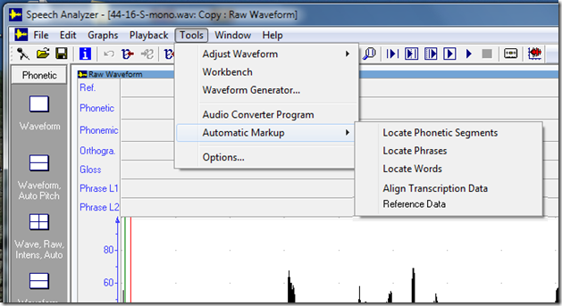
When selected, the dialog box should allow a user to either:
1) Auto number the current fields starting at the number 1.
or
2) Customize the numbering by allowing the user specify the Start and Stop numbers.
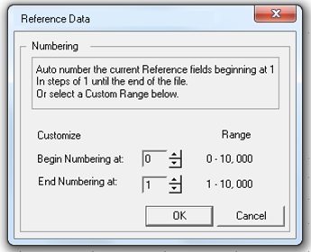
I recommend that you do a test first of the file, and determine the number of Words that are currently marked, then prefill the Begin and End numbers with the actual numbers that will be used. That is re-setting the Begin to 1 and the end to the actual total number.
If there are no Reference fields in the file, then disable the OK button. As a help to users show a pop-up that says:
No Reference fields were found. First enter
Word breaks to enable the Reference fields.
Note: A Reference data segments is the size of it’s Word segment, and only exists after a Word segment has been created.
As a test Open ChFrench, and manually enter numbers in the Reference Transcription field. Either click in the Reference field to hi-lite a word-sized region, or use the Next Segment button in the Tool Bar to navigate. Manually enter the numbers 1 to 10 in the current blank Reference fields.
Note the bug regarding the last segment, number 10, in which it will not retain the number when you leave that field.
#2
In Tools/ Automatic Markup/ Align Transcription Data
Add “Gloss” to the Modify list:
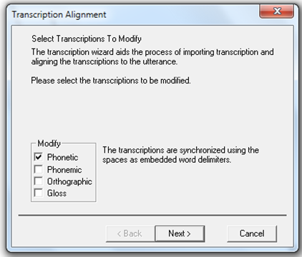
When selected, it should show Gloss data, and the same options as the other choices. Insert the data into the Gloss field.
Note the bug when one of the current choices is selected, and using the default options, the data is incorrectly aligned.
Terry

10/29/2012-Splite File Work#2
Kent,
In the Split File dialog box:
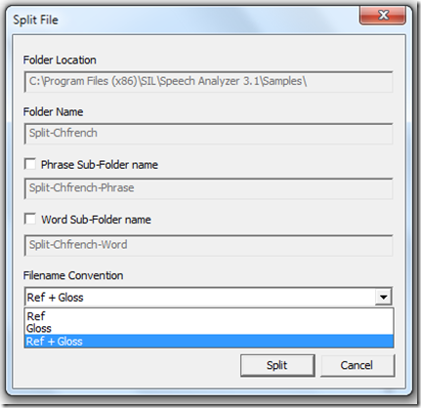
Would you add a “Ref” option in Filename Convention.
Then would you add a full featured filename selection dialog box for “Folder Location”, but leave the current default.
And would you enable edition of the “Folder Name” field.
Would you also change the name from “Word Sub-Folder name” to “Gloss Sub-Folder name”.
And the default from “Split-Chfrench-Word” to “Split-Chfrench-Gloss”.
Also, if the user selects the new “Ref” Filename Convention option, then put the Ref numbered files directly into the “Folder Name” and not a Sub-Folder.
The purpose of these changes is to allow a user to chunk up a file for which they have not data to enter into SA.
The assumption is that the user will use SA at a later to enter the data for each small file, or may never enter the data via SA but use another program (like a database program or Excel spreadsheet) as the ‘holder’ of the data and just reference the small files that SA just made as needed for each entry in that program.
Terry

10/29/2012 Gloss Transcription

Kent,
There is bug in the current MSEA version 3.0.1.12 which is not in the older SIL 3.0.1 nor in the new SIL version 3.1
To see the bug do this:
Run SA 3.0.1.12
In the Start Mode dialog box, click Record.
Press the Rec button and make a new 5 second Recording.
During the record process clap your hands three times slowly, then press Stop and Done.
Show the Phonetic and Gloss transcription fields of this new recording.
Place the Begin and End cursors around the Third hand-clap, then press the Add Word Segment icon.
Note that the Gloss segment is selected (which is correct behavior).
Now click on the Phonetic place holder and note it selects correctly.
Now put the Begin cursor just before the First hand-clap and the End just beyond the First hand-clap.
Now press the Add Word Segment icon.
Note that the Gloss segment is in the wrong place, but the Phonetic segment is located correctly.
Now click on the Phonetic segment and notice for the # Gloss marker suddenly shows up in the correct place.
Now click on that Gloss segment and note the selector jumps to the Third hand-clap Gloss segment. This is the bug.
Click around to get a feel for what does work and what does not work.
I believe this bug is caused by the End of Third Gloss segment exceeding the length of the file (it should stop one pixel before the end of the file), which explains why initially the First Segment Gloss is left of it’s correct location.
As a secondary test to confirm my suspicion and so you can see the normal behavior of SA.
First click the Undo icon several times to remove all segmental edits.
Do segmenting again, but this time, first mark the First hand-clap Gloss, then the Second hand-clap Gloss, and then the Third hand-clap Gloss. Note that this all work well and the segments are in the correct locations. Click around and note all segment are selectable except for First hand-clap Gloss and Second hand-clap Gloss which both jump to Third hand-clap Gloss. Confirmation of the bug.
Terry

10/29/2012 – Gloss Segment Design Change
Kent,
After you fix the Gloss transcription bug, so that the MSEA version works like the current SIL release, then I would like to make a design change in how the Gloss segmenting process works.
I don’t remember the reason, but Alec felt that once a first Gloss segment was marked in a file, then the end of that segment should be the end of the file, and not the position of the End cursor. All Gloss segments currently respect the End cursor position except the last one in the file. I now believe that is not a good idea since it prevents a user from having the ending boundary of the last Gloss segment be less than the end of the file, which is not necessary requirement.
So the design change would be to mark all Gloss segments using both the Begin and End cursors; even if it were the only Gloss segment in the file or the last Gloss segment in a series of Gloss segments.
This change can wait until the work on Split File has been done.
Terry

10/29/2012 – Background Artifacts
Kent,
SA 3.01 had background artifacts when the waveform was zoomed-in and panned left or right.
This was fixed in the MSEA version. I thought this bug was fixed in the 3.1 release, but I just noticed it’s not fixed.
Am I missing something?
Terry

10/30/2012 – New Export Options
Kent,
Would you revise the File/ Export “Export Speech Format” dialog by adding an option for “Multi-Record”, by changing the dialog box to this:
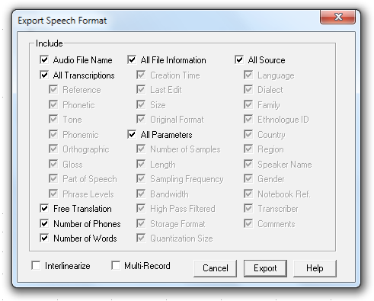
The attached files show the expected output for either an SFM or XML export.
Note:
Additional code will be needed in order to gray-out the “Interlinearize” option when an XML export is chosen (this is currently a bug). Or it could be hidden if that’s easier. And would you re-order the data such that Reference is first in the list and not last.
Also, additional code will be needed to gray-out the option that is ‘not’ chosen when doing an SFM export so that a user cannot select both “Interlinearize” and “Multi-Record” at the same time. You could use Radio-Buttons in this case, but that is more work.
Terry

7/12/12 - Stereo Issue
Here is a problem that is caused by SA not allowing the selection of the Waveform when a Stereo file is in use. Alec disabled this option since SA only shows the Left channel of the stereo file and altering one channel and not the other would cause problems. My idea for now is to enable Select Waveform (Ctrl-A or using click and drag), but continue to disable the Paste and Cut options. It seems that the Paste as New File option could be allowed without causing problems.
What do you think?
Terry
P.S. I suppose the real answer is to alter the hidden Right channel when the Left is changed during a waveform edit.
From:Sigrid
Sent: July 10, 2012 10:05 PM
To: Terry Gibbs
Subject: question on SA
Dear Terry,
I hope this finds you well.
I am working with speech analyzer to get a phonology and orthography going and am facing a little problem. I can't select or cut anything.
Ellie Hall took a look and couldn't figure out why. Then she had me send her one of my WAV files, and she couldn't do it on her computer, either.
So it must be the file, not the program. Do you have any idea what to do?
Thank you for any advice,
Ziggi
From: Ellie Hall
Sent: July 11, 2012 8:46 AM
To: 'John Ross' ; 'Cambell Prince' ; 'Terry Gibbs'
Subject: RE: speech analyzer
Hi again,
Finally realized that we never actually tried the files on MY computer, so I got one from Ziggi and tried it.
It is a WAV file, but I have the same problems- cant select a waveform for editing. So it does seem to be the file (actually quite a lot of them).
I dont know that much about file formats, but I think there is maybe really more than one type of WAV file?
Could it still be a format problem, or perhaps something to do with sampling rates, etc?
The file I have on my computer is small enough to email if someone would like to look at it.
Ellie
--------------------------------------------------------------------------------
From: John Ross [mailto:john_ross@sil.org]
Sent: Wednesday, July 11, 2012 3:00 PM
To: Cambell Prince; Ellie Hall; Terry Gibbs
Subject: RE: speech analyzer
Ellie,
It might be related to the file type.
I think SA can edit WAV files but might not be able to edit MP3 files. Do you know the audio file type that was being used?
John
--------------------------------------------------------------------------------
From: Cambell Prince
Sent: 7/11/2012 1:58 PM
To: Ellie Hall; John Ross; Terry Gibbs
Subject: Re: speech analyzer
Hi,
I don't have any experience with SA myself. But John Ross or Terry Gibbs may be able to help
Regards,
Cambell
On 11/07/2012 1:21 p.m., Ellie Hall wrote:
Hi,
Yesterday I was trying to help Ziggi - she was asking me how to edit an audio file within SA, and I found the reason she couldnt do it was that the option to select the waveform simply wasnt available; it was grayed out, and the shortcut keys didnt work either.
You could play files normally, but you couldnt use the editing functions.
It was set up with XP on a virtual machine (VMWare, I think) on a Macbook Pro.
I uninstalled it and put her on the most recent version that just came out the other week- same problem.
Also I checked, and she has the .NET.
I was wondering if any of you guys here have run into this and might know what is going on, or whether this is something to ask on the LTS list.
I know we have plenty of Mac users in our group, but not all of them are using SA, and I dont think they all set up their Windows boxes the same way.
I put FLEx and Phonology assistant on her machine, and they work fine so far- at least the things we tried. Do you have any thoughts on this?
Thanks,
Ellie
--------------------------------------------------------------------------------
Cambell Prince
Payap Language Software and SIL MSEAG
Skype: cambell.prince | Mobile: +66 87 190 5871
www.palaso.org and www.sil.org

8/15/12 - Exception On Open
Attachments: 96KHz-24bit Original.WAV
Here is what I got when opening this 13 second 96-24 stereo file. But on the second attempt, I only got the first error dialog, and then SA opened the file, and all functions worked.
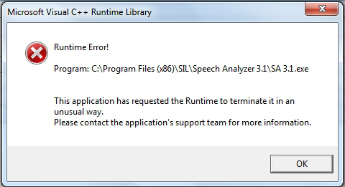

8/15/12 – Spectrogram Resolution Problem
Here is a comparison of three recording frequencies and how the Spectrogram resolution improves.
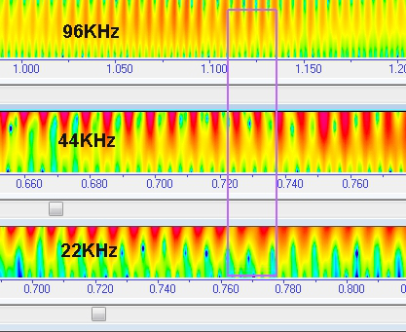

10/31/12 - Player Bug
This is a non Split File bug.
The Player dialog box includes Play, Stop and Pause buttons for use in playing back a file back at slow speed.
The Pause button works correctly, but the Blue playback cursor does not stop moving, and continues to the end of the file.
No audio is heard during Pause, and resuming Pause proceeds from the paused point. The Speed setting does not matter.
The bug is that the Blue cursor does not stop moving, everything else seems to be fine.

From 12/14/12
Kent,
There is a bug in the Playback/ Player.
If Play button is pressed, and then Pause is pressed, then the audio is correctly paused, and the audio will correctly continue on from that point when Pause is pressed a second time to continue, however the Blue playback cursor never stops moving.......
Terry

10/31/12 - SA 3.0.1.13 bugs
Thanks for working on this.
Here are some things that need to be done:
1) The ‘data change flag’ in SA is not being set after the number are placed in the Reference fields, thus the Save option is not enabled.
2) If I set the numbers to start at 5 and end at 10, then set the numbers to start at 1 and end at 10, I get this result.
Since Ref. numbers should be unique in each file, I suggest that you overwrite existing data.
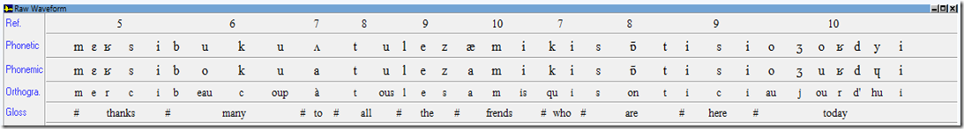
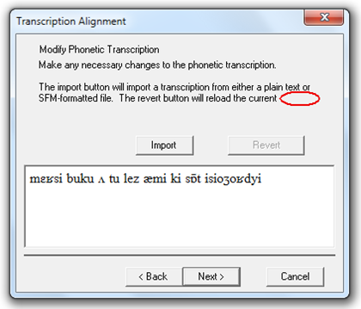
3) Add “text.” to the end of the second sentence.

4) Capitalize “finish” to“Finish” and “undo” to “Undo”.
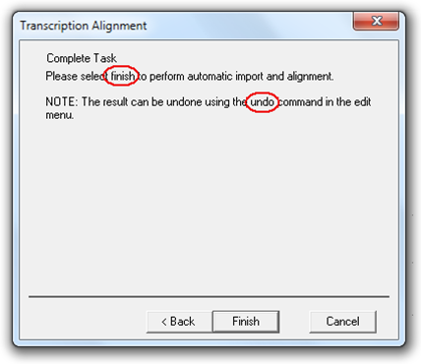

10/29/12 - Gloss Transcription Bug
There is bug in the current MSEA version 3.0.1.12 which is not in the older SIL 3.0.1 nor in the new SIL version 3.1
To see the bug do this:
Run SA 3.0.1.12
In the Start Mode dialog box, click Record.
Press the Rec button and make a new 5 second Recording.
During the record process clap your hands three times slowly, then press Stop and Done.
Show the Phonetic and Gloss transcription fields of this new recording.
Place the Begin and End cursors around the Third hand-clap, then press the Add Word Segment icon.
Note that the Gloss segment is selected (which is correct behavior).
Now click on the Phonetic place holder and note it selects correctly.
Now put the Begin cursor just before the First hand-clap and the End just beyond the First hand-clap.
Now press the Add Word Segment icon.
Note that the Gloss segment is in the wrong place, but the Phonetic segment is located correctly.
Now click on the Phonetic segment and notice for the # Gloss marker suddenly shows up in the correct place.
Now click on that Gloss segment and note the selector jumps to the Third hand-clap Gloss segment. This is the bug.
Click around to get a feel for what does work and what does not work.
I believe this bug is caused by the End of Third Gloss segment exceeding the length of the file (it should stop one pixel before the end of the file), which explains why initially the First Segment Gloss is left of it’s correct location.
As a secondary test to confirm my suspicion and so you can see the normal behavior of SA.
First click the Undo icon several times to remove all segmental edits.
Do segmenting again, but this time, first mark the First hand-clap Gloss, then the Second hand-clap Gloss, and then the Third hand-clap Gloss. Note that this all work well and the segments are in the correct locations. Click around and note all segment are selectable except for First hand-clap Gloss and Second hand-clap Gloss which both jump to Third hand-clap Gloss. Confirmation of the bug.

11/1/12 – Caption Bar Bug

Kent,
These are non Split File bugs.
Here are two bug in the SA 3.1 SIL Release.
These bugs were fixed in the MSEA version, but they seem to not be fixed in the Release code.
I thought you did a Merge of the code bases?
The bugs are:
1) Incorrect font size in Caption bar.
2) Large Bar with Caption not positioned correctly.
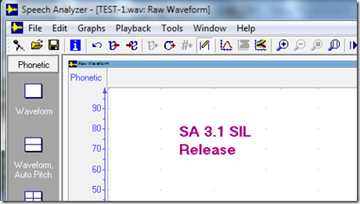
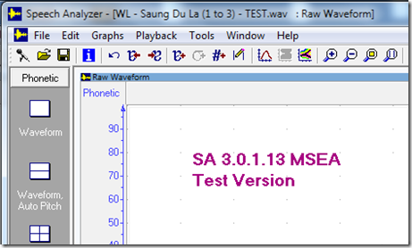
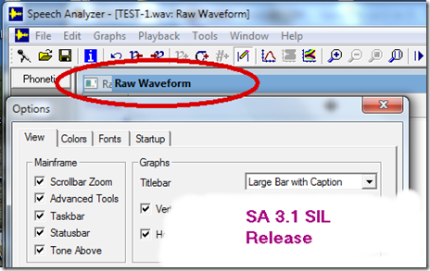
Terry

11/5/12 – Cut and paste GPF
Kent,

This file will be useful for us to talk about and use for our Wordlist testing.

BTW, if you select some of the waveform and do a Copy and Paste As New File, then it will GPF both the 3.1 Release and the current 1.14 test version.
Attachments:
WL - Saung Du La (intro-10) - Test.saxml42 bytes
WL - Saung Du La (intro-10) - Test.wav27 bytes

11/5/12 – Cursor Size
When you have time, after most of the current Split File work is done, would you revise the Options dialog box as I have indicated below, and provide a way to make the cursors easier to see. I think the cursors are currently 1 pixel wide, but in any case use Small to be the current size, Medium to be two time Small, and Large to be three time Small.

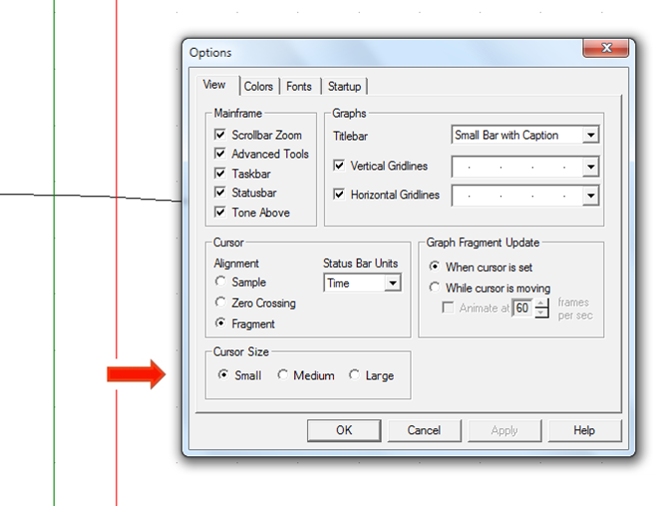

11/5/12 – Reference Bug
The bug in the Ref transcription can be easily seen if you open ChFrench.
If you don’t already have the Ref field numbered, then do that, and then starting at number 10, delete that number, then click on number 9 and delete it and so on, moving left.
Notice that as you do this, the Ref number you are about to delete grows longer and longer to mark more and more of the file.
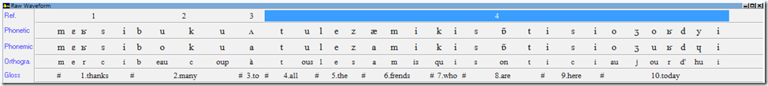
This is a bug, since a single Ref number should never line up with more than one Gloss word.
This should be reported to JAARS as a bug in 3.1
I hope if we find enough bugs and enough good features we can sell as useful, then we can have another Release
Terry

In the Ref bug email I just sent, I now notice that I did not explicitly say that I originally found the bug in 1.14. After finding it I looked at 3.1 and it also has the bug. So 1.14 needs fixing now, and a some point let JAARS know 3.1 needs this fixed.

11/8/12 – Copy Bug
In SA 3.1 and SA 1.14, there is a bug in the File\ Copy function.
If the selected segment has some data, then that data is put on the Clipboard, however if the segment does not have data, then SA uses the File\ Copy Measurements menu option and copies that data to the Clipboard, which is not correct.

The correct behavior would be to copy nothing to the Clipboard if the segment is blank.

11/21/12 – Add Phonetic Segment revision
There is either a bug or a design error that is preventing the adding of a Phonetic segment. This issue exists in: 0.16, 3.1 and the old 2.7
Using ChFrench as a test file (but any file will work), after marking a few Words (and getting a single Phonetic segment for each Word), then when a Word is selected, the “Add Word Segment” icon is not enabled,
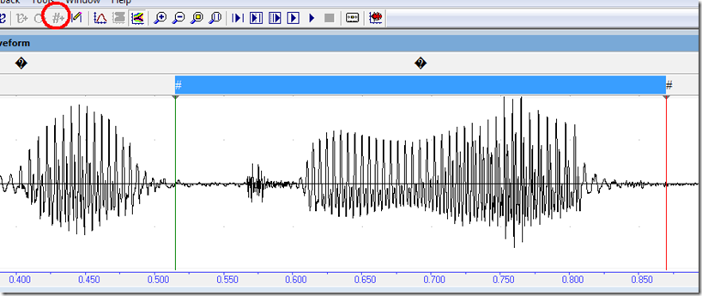
This is correct behavior, since a new Word cannot be added directly on top of the existing Word (the cursors are on existing Word boundaries).
But if I move the Begin cursor into the existing Word region, then SA enables the “Add Word Segment” icon, and I can add a new Word starting location.
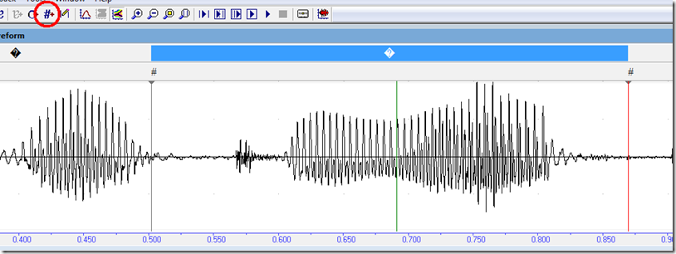

In a like manner, when a Phonetic segment is selected, then a new Phonetic segment cannot be added:
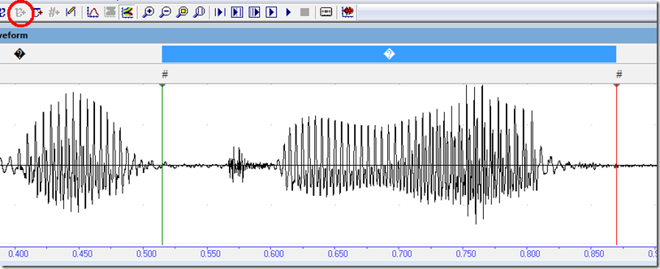
The problem is, if I move the Begins cursor into the segment, then SA does not enable the “Add Phonetic Segment” icon:
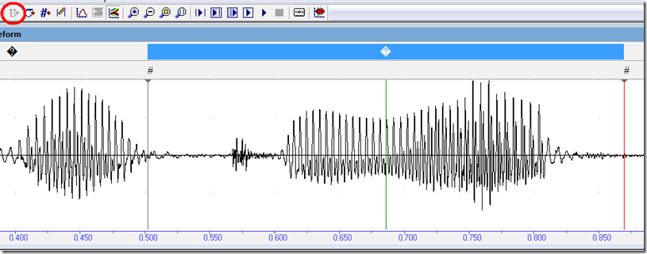
The work around to this problem, is to de-select the Phonetic segment, by pressing the Esc key:

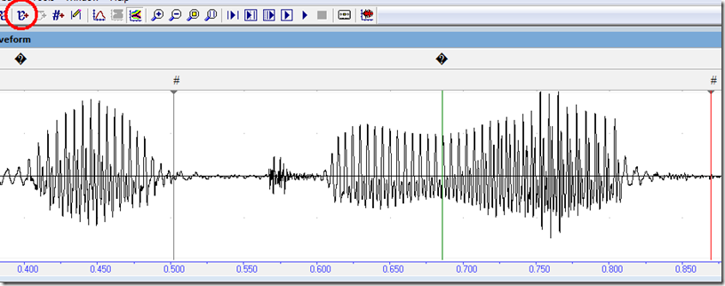
But this is hard for users to remember to do.
So would you revise the “Add Phonetic Segment” code so it behaves like “Add Word Segment” ?

11/28/12 – FW POS Export #2
I forgot to include this Format dialog that also need to be revised.

